**Information Technology Institute**

**Full stack.net Track**

**Database project:**

**Examination system**

**Supervisor:**

**Eng/Sar****a Salah**

**Presented by:**

**1-Al-zahraa Shaban Elsayed**

**2-Rana Ali Hassan**

**3-Asmaa Ahmad Fathy**

**4-Melad Malak Shehata**

**5-Mohamed Elsayed Mohamed**

.

Database design ERD

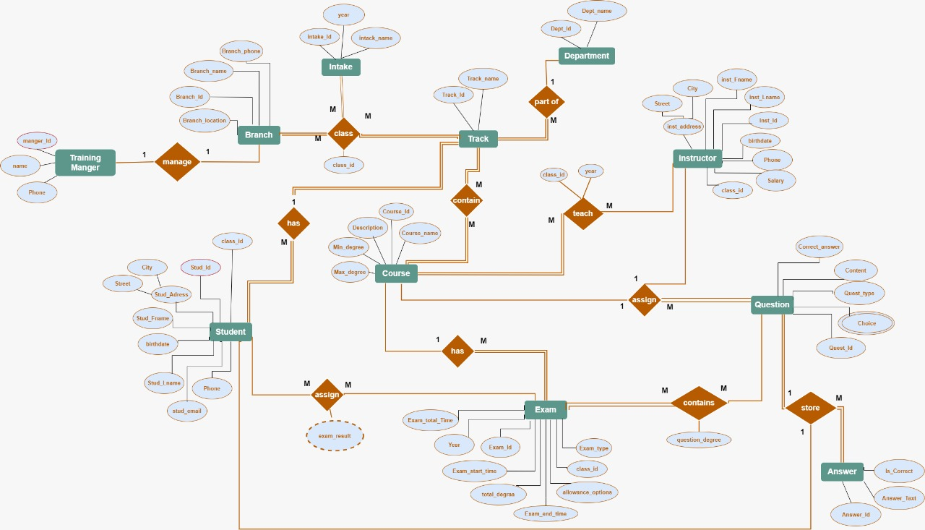

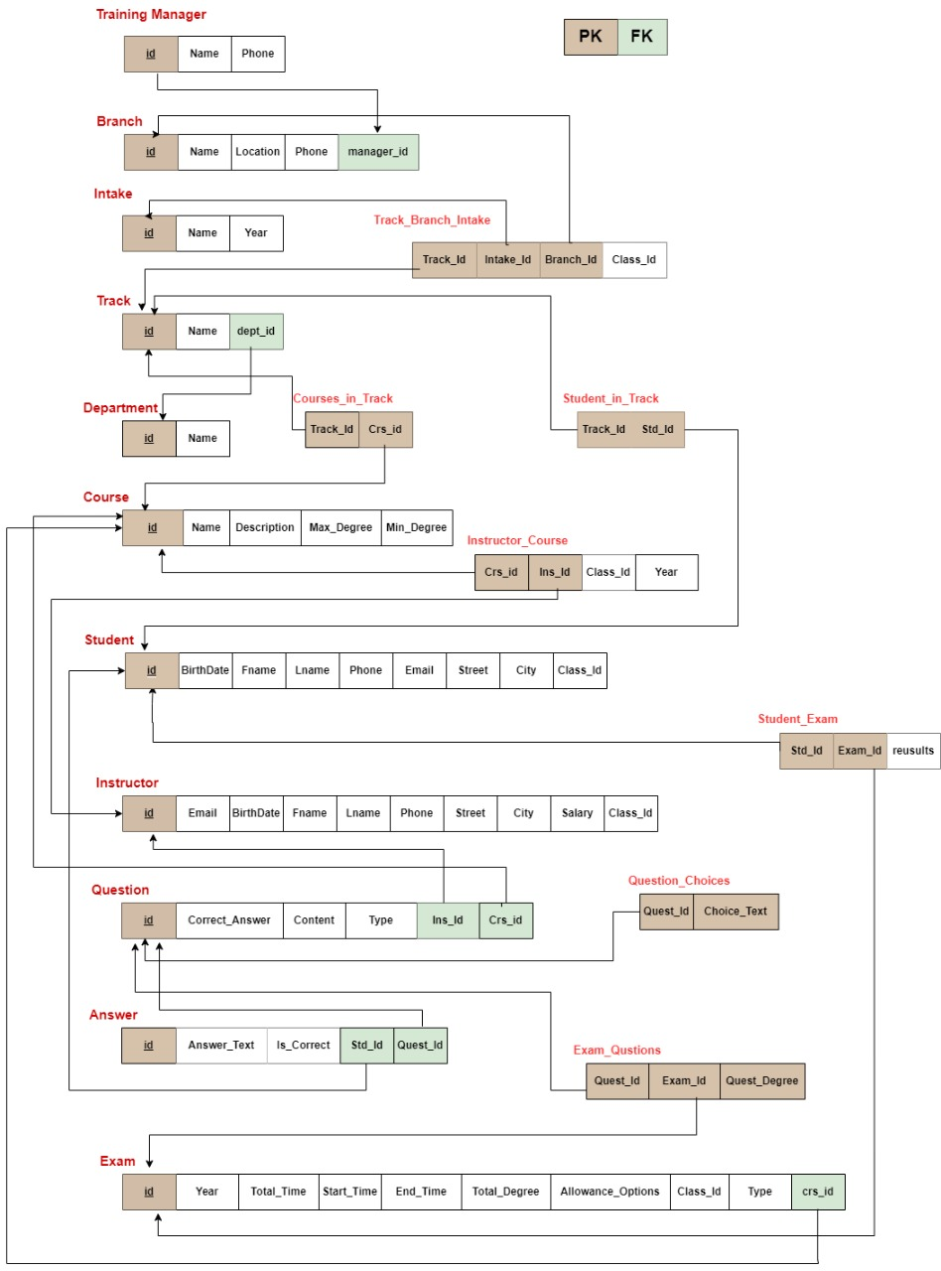



Project / Servers / . / User databases

User databases

User databases **1**

ExamSystem

Project / Servers / . / User databases / ExamSystem



# ExamSystem

Description

Properties

|  |  |
| --- | --- |
| **Name** | **Value** |
| SQL Server version | Microsoft SQL Server RTM 15.0.2130.3 |
| Compatibility level | SQL Server 2019 |
| Last backup time | 1/15/2025 6:06:01 PM |
| Last backup time of transaction log | N/A |
| Default index fill factor (%) | 0 |
| Creation date | 1/15/2025 6:16:16 PM |
| Number of Users | 4 |
| Database Encryption Enabled | **False** |
| Database Encryption Algorithm | N/A |
| Database status | ONLINE |
| Max size | 0 B |
| Database size (Mb) | 45 |
| Unallocated data space (Mb) | 35.06 |
| Default language | N/A |
| Default fulltext language | us_english |

Object Types **6**

Tables Views

Stored Procedures

User-Defined Table Types Database Roles Schemas

Options

|  |  |
| --- | --- |
| **Name** | **Value** |
| Database collation | SQL_Latin1_General_CP1_CI_AS |
| Restrict access | MULTI_USER |
| Cleanly shutdown | **False** |
| Supplemental logging enabled | **False** |
| Is Read-Only | **False** |
| Auto close | **False** |
| Auto shrink | **False** |

|  |  |
| --- | --- |
| Database is read-only for restore log | **False** |
| Is Snapshot | **False** |
| Snapshot isolation state | **False** |
| Read committed snapshot on | **False** |
| Recovery model | FULL |
| Page verify option | Checksum |
| Auto create statistics | **True** |
| Auto update statistics | **True** |
| Auto update statistics asynchronously | **False** |
| ANSI NULL default | **False** |
| ANSI NULL enabled | **False** |
| ANSI padding enabled | **False** |
| ANSI warnings enabled | **False** |
| Arithmetic abort enabled | **False** |
| Concatenating NULL yields NULL | **False** |
| Numeric roundabort enabled | **False** |
| Quoted Identifier ON | **False** |
| Recursive triggers enabled | **False** |
| Close cursors on commit | **False** |
| Local cursor by default | **False** |
| Fulltext enabled | **True** |
| Trustworthy | **False** |
| Database chaining | **False** |
| Forced parameterization | **False** |
| Master key encrypted by server | **False** |
| Published | **False** |
| Merge published | **False** |
| Is distribution database | **False** |
| Sync with backup | **False** |
| Service broker GUID | 081da73a-9e3e-4c6c-ab68-1ce5800b8eeb |
| Service broker enabled | **False** |
| Log reuse wait | Nothing |
| Date correlation | **False** |
| Change data capture enabled | **False** |
| Honor broker priority | **False** |
| Database owner | DESKTOP-1GUCVM9\KE |
| Delayed durability | Disabled |



|  |  |
| --- | --- |
| Containment type | **False** |



Database Files **5**

|  |  |  |  |  |  |
| --- | --- | --- | --- | --- | --- |
| **Name** | **Type** | **Size** | **Max size** | **Autogrowth** | **File Name** |
| ExamSystem_Data | Rows | 10,240  KB | 51,200  KB | 5,120 KB | C:\Program Files\Microsoft SQL Server\MSSQL15.MSSQLSERVER\MSSQL\DATA\ExamSystem_Data.mdf |
| ExamSystem_Log | Log | 5,120  KB | 25,600  KB | 5,120 KB | C:\Program Files\Microsoft SQL Server\MSSQL15.MSSQLSERVER\MSSQL\DATA\ExamSystem_Log.ldf |
| ExamSystem_DataFG1 | Rows | 10,240  KB | 51,200  KB | 5,120 KB | C:\Program Files\Microsoft SQL Server\MSSQL15.MSSQLSERVER\MSSQL\DATA\ExamSystem_DataFG1.ndf |
| ExamSystem_DataFG2 | Rows | 10,240  KB | 51,200  KB | 5,120 KB | C:\Program Files\Microsoft SQL Server\MSSQL15.MSSQLSERVER\MSSQL\DATA\ExamSystem_DataFG2.ndf |
| ExamSystem_DataFG3 | Rows | 10,240  KB | 51,200  KB | 5,120 KB | C:\Program Files\Microsoft SQL Server\MSSQL15.MSSQLSERVER\MSSQL\DATA\ExamSystem_DataFG3.ndf |

Project / Servers / . / User databases / ExamSystem / Tables



# Tables

Objects **20**

|  |  |
| --- | --- |
| **Name** | **Description** |
| dbo.answers |  |
| dbo.audit_Course |  |
| dbo.audit_track_insert_update_delete |  |
| dbo.Branch |  |
| dbo.Branch_Track_Intake |  |
| dbo.Course |  |
| dbo.Courses_in_Track |  |
| dbo.Department |  |
| dbo.Exam |  |
| dbo.Exam_Questions |  |
| dbo.Instructor |  |
| dbo.Instructor_Course |  |
| dbo.Intake |  |
| dbo.Question |  |
| dbo.Question_Choices |  |
| dbo.Student_Exam |  |
| dbo.Student_in_Track |  |
| dbo.Track |  |
| dbo.training_manager |  |
| std.Student |  |

Project / Servers / . / User databases / ExamSystem / Tables / dbo.answers



# dbo.answers

Description

Properties

|  |  |
| --- | --- |
| **Name** | **Value** |
| File Collation |  |
| File Group | exam_FG3 |
| Filestream File Group |  |
| Is Partitioned | **False** |
| Partitioned Column |  |
| Partition Scheme |  |
| File Groups |  |
| Filestream Partition Scheme |  |
| Filestream File Groups |  |
| Heap | **False** |
| Full Text Catalog |  |
| Full Text |  |
| Compression | NONE |
| Row Count (~) | 7 |
| Created | 1/15/2025 4:50:23 PM |
| Last Modified | 1/15/2025 5:10:08 PM |

Columns **4**

|  |  |  |  |  |  |  |  |  |  |  |  |  |
| --- | --- | --- | --- | --- | --- | --- | --- | --- | --- | --- | --- | --- |
| **Key** | **Name** | **Data Type** | **Length** | **Precision** | **Scale** | **Not Null** | **Identity** | **Rule** | **Default** | **Computed** | **Persisted** | **Description** |
|  | std_id | int | 4 | 10 | 0 | **True** |  |  |  | **False** | **False** |  |
|  | quest_id | int | 4 | 10 | 0 | **True** |  |  |  | **False** | **False** |  |
|  | answer_text | varchar | 300 | 0 | 0 | **False** |  |  |  | **False** | **False** |  |
|  | is_correct | bit | 1 | 1 | 0 | **False** |  |  |  | **False** | **False** |  |

Indexes **1**

|  |  |  |  |  |  |
| --- | --- | --- | --- | --- | --- |
| **Key** | **Name** | **Columns** | **Unique** | **Type** | **Description** |
|  | PK answers C2A2B5B61835B804 | std_id, quest_id | **True** |  |  |

Triggers **2**

|  |  |  |  |  |  |
| --- | --- | --- | --- | --- | --- |
| **Name** | **ANSI Nulls ON** | **Quoted Identifier ON** | **On** | **Not For Replication** | **Description** |
| trg_updatestudentresults | **True** | **True** | AFTER INSERT, UPDATE | **False** |  |
| trig_student_question_exam | **True** | **True** | AFTER INSERT | **False** |  |



Foreign Keys **2**

|  |  |  |  |  |  |
| --- | --- | --- | --- | --- | --- |
| **Name** | | | | **Columns** | **Description** |
| FK | answers | quest_i | 68487DD7 | Id |  |
| FK | answers | std_id | 6754599E | Id |  |

SQL Script

CREATE TABLE dbo.answers ( std_id int NOT NULL, quest_id int NOT NULL,

answer_text varchar(300) NULL, is_correct bit NULL,

PRIMARY KEY CLUSTERED (std_id, quest_id) ON exam_FG3

)

ON exam_FG3 GO

## SET QUOTED_IDENTIFIER, ANSI_NULLS ON GO

create or alter trigger dbo.trg_updatestudentresults on answers

after insert , update as

begin

update student_exam set results = (

select isnull(sum(eq.quest_degree), 0) from answers a

inner join exam_questions eq on a.quest_id = eq.quest_id

where a.std_id = student_exam.std_id and a.is_correct = 1 and eq.exam_id = student_exam.exam_id

)

print ('Updated Resulte Of Student') end

## GO

CREATE OR ALTER TRIGGER dbo.trig_student_question_exam ON answers

## AFTER INSERT

AS BEGIN

DECLARE @StudentId INT, @QuestionId INT, @AnswerText NVARCHAR(MAX), @CorrectAnswer NVARCHAR(MAX);

‐‐select data insertrd from insertred table SELECT

@StudentId = INSERTED.Std_Id, @QuestionId = INSERTED.Quest_Id, @AnswerText = INSERTED.Answer_Text

## FROM INSERTED;

‐‐set coreect answer in the varaiable SELECT

@CorrectAnswer = Correct_Answer FROM

Question WHERE

Id = @QuestionId;

‐‐if the answer correct set 1 else set 0 UPDATE Answers

SET Is_Correct = CASE

WHEN @AnswerText = @CorrectAnswer THEN 1 ELSE 0

## END



Depends On **5**

ExamSystem

dbo.Exam_Questions dbo.Question dbo.Student_Exam std.Student

Used By **2**

dbo.GetStudentIncorrectAnswers dbo.sp_insertStudentQuestionAnswers

WHERE

Std_Id = @StudentId AND Quest_Id = @QuestionId;

END; GO

ALTER TABLE dbo.answers

ADD FOREIGN KEY (quest_id) REFERENCES dbo.Question (Id) ON DELETE CASCADE ON UPDATE CASCADE GO

ALTER TABLE dbo.answers

ADD FOREIGN KEY (std_id) REFERENCES std.Student (Id) ON DELETE CASCADE ON UPDATE CASCADE GO

Project / Servers / . / User databases / ExamSystem / Tables / dbo.audit_Course



# dbo.audit_Course

Description

Properties

|  |  |
| --- | --- |
| **Name** | **Value** |
| File Collation |  |
| File Group |  |
| Filestream File Group |  |
| Is Partitioned | **False** |
| Partitioned Column |  |
| Partition Scheme |  |
| File Groups |  |
| Filestream Partition Scheme |  |
| Filestream File Groups |  |
| Heap | **True** |
| Full Text Catalog |  |
| Full Text |  |
| Compression | NONE |
| Row Count (~) | 0 |
| Created | 1/15/2025 5:09:04 PM |
| Last Modified | 1/15/2025 5:09:04 PM |

Columns **7**

|  |  |  |  |  |  |  |  |  |  |  |  |  |
| --- | --- | --- | --- | --- | --- | --- | --- | --- | --- | --- | --- | --- |
| **Key** | **Name** | **Data Type** | **Length** | **Precision** | **Scale** | **Not Null** | **Identity** | **Rule** | **Default** | **Computed** | **Persisted** | **Description** |
|  | users_name | nvarchar | 35 | 0 | 0 | **False** |  |  |  | **False** | **False** |  |
|  | Id | int | 4 | 10 | 0 | **False** |  |  |  | **False** | **False** |  |
|  | Name | varchar | 50 | 0 | 0 | **False** |  |  |  | **False** | **False** |  |
|  | Description | varchar | 200 | 0 | 0 | **False** |  |  |  | **False** | **False** |  |
|  | Max_Degree | int | 4 | 10 | 0 | **False** |  |  |  | **False** | **False** |  |
|  | Min_Degree | int | 4 | 10 | 0 | **False** |  |  |  | **False** | **False** |  |
|  | modification_date | date | 3 | 10 | 0 | **False** |  |  |  | **False** | **False** |  |

SQL Script

CREATE TABLE dbo.audit_Course ( users_name nvarchar(35) NULL, Id int NULL,

Name varchar(50) NULL, Description varchar(200) NULL, Max_Degree int NULL, Min_Degree int NULL,

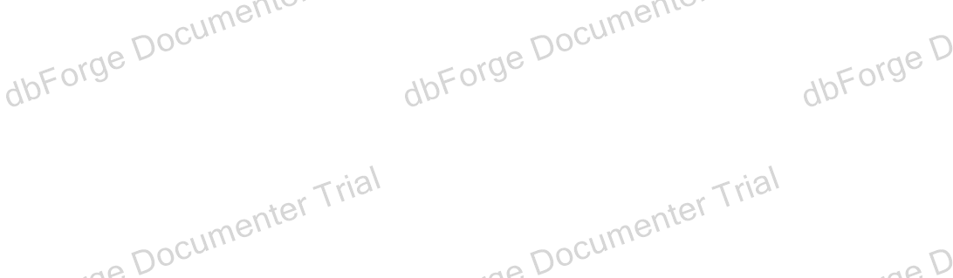

Depends On **1**

ExamSystem

Used By

No items found

modification_date date NULL

)

ON [PRIMARY] GO

Project / Servers / . / User databases / ExamSystem / Tables / dbo.audit_track_insert_update_delete



# dbo.audit_track_insert_update_delete

Description

Properties

|  |  |
| --- | --- |
| **Name** | **Value** |
| File Collation |  |
| File Group |  |
| Filestream File Group |  |
| Is Partitioned | **False** |
| Partitioned Column |  |
| Partition Scheme |  |
| File Groups |  |
| Filestream Partition Scheme |  |
| Filestream File Groups |  |
| Heap | **True** |
| Full Text Catalog |  |
| Full Text |  |
| Compression | NONE |
| Row Count (~) | 1 |
| Created | 1/15/2025 5:08:02 PM |
| Last Modified | 1/15/2025 5:08:02 PM |

Columns **5**

|  |  |  |  |  |  |  |  |  |  |  |  |  |
| --- | --- | --- | --- | --- | --- | --- | --- | --- | --- | --- | --- | --- |
| **Key** | **Name** | **Data Type** | **Length** | **Precision** | **Scale** | **Not Null** | **Identity** | **Rule** | **Default** | **Computed** | **Persisted** | **Description** |
|  | trake_id | int | 4 | 10 | 0 | **False** |  |  |  | **False** | **False** |  |
|  | track_name | nvarchar | 30 | 0 | 0 | **False** |  |  |  | **False** | **False** |  |
|  | track_date | date | 3 | 10 | 0 | **False** |  |  |  | **False** | **False** |  |
|  | tuser_name | nvarchar | 30 | 0 | 0 | **False** |  |  |  | **False** | **False** |  |
|  | new_track_name | nvarchar | 30 | 0 | 0 | **False** |  |  |  | **False** | **False** |  |

SQL Script

CREATE TABLE dbo.audit_track_insert_update_delete ( trake_id int NULL,

track_name nvarchar(30) NULL, track_date date NULL, tuser_name nvarchar(30) NULL,

new_track_name nvarchar(30) NULL

)

ON [PRIMARY] GO



Depends On **1**

ExamSystem

Used By

No items found

Project / Servers / . / User databases / ExamSystem / Tables / dbo.Branch



# dbo.Branch

Description

Properties

|  |  |
| --- | --- |
| **Name** | **Value** |
| File Collation |  |
| File Group | exam_FG1 |
| Filestream File Group |  |
| Is Partitioned | **False** |
| Partitioned Column |  |
| Partition Scheme |  |
| File Groups |  |
| Filestream Partition Scheme |  |
| Filestream File Groups |  |
| Heap | **False** |
| Full Text Catalog |  |
| Full Text |  |
| Compression | NONE |
| Row Count (~) | 5 |
| Created | 1/15/2025 3:29:50 PM |
| Last Modified | 1/15/2025 3:30:12 PM |

Columns **4**

|  |  |  |  |  |  |  |  |  |  |  |  |  |
| --- | --- | --- | --- | --- | --- | --- | --- | --- | --- | --- | --- | --- |
| **Key** | **Name** | **Data Type** | **Length** | **Precision** | **Scale** | **Not Null** | **Identity** | **Rule** | **Default** | **Computed** | **Persisted** | **Description** |
|  | Id | int | 4 | 10 | 0 | **True** | 1 - 1 |  |  | **False** | **False** |  |
|  | Name | varchar | 30 | 0 | 0 | **False** |  |  |  | **False** | **False** |  |
|  | location | varchar | 40 | 0 | 0 | **False** |  |  |  | **False** | **False** |  |
|  | manager_id | int | 4 | 10 | 0 | **False** |  |  |  | **False** | **False** |  |

Indexes **1**

|  |  |  |  |  |  |
| --- | --- | --- | --- | --- | --- |
| **Key** | **Name** | **Columns** | **Unique** | **Type** | **Description** |
|  | PK Branch 3214EC07665931C7 | Id | **True** |  |  |

Foreign Keys **1**

|  |  |  |
| --- | --- | --- |
| **Name** | **Columns** | **Description** |

|  |  |  |
| --- | --- | --- |
| FK Branch manager 33D4B598 | manager_id |  |



SQL Script

Depends On **2**

ExamSystem

dbo.training_manager

Used By **3**

dbo.newmanager_proc dbo.sp_getbranchdetails dbo.Branch_Track_Intake

CREATE TABLE dbo.Branch ( Id int IDENTITY,

Name varchar(30) NULL, location varchar(40) NULL, manager_id int NULL,

PRIMARY KEY CLUSTERED (Id) ON exam_FG1

)

ON exam_FG1 GO

ALTER TABLE dbo.Branch

ADD FOREIGN KEY (manager_id) REFERENCES dbo.training_manager (manager_id) GO

Project / Servers / . / User databases / ExamSystem / Tables / dbo.Branch_Track_Intake



# dbo.Branch_Track_Intake

Description

Properties

|  |  |
| --- | --- |
| **Name** | **Value** |
| File Collation |  |
| File Group |  |
| Filestream File Group |  |
| Is Partitioned | **False** |
| Partitioned Column |  |
| Partition Scheme |  |
| File Groups |  |
| Filestream Partition Scheme |  |
| Filestream File Groups |  |
| Heap | **False** |
| Full Text Catalog |  |
| Full Text |  |
| Compression | NONE |
| Row Count (~) | 8 |
| Created | 1/15/2025 3:28:10 PM |
| Last Modified | 1/15/2025 3:30:12 PM |

Columns **3**

|  |  |  |  |  |  |  |  |  |  |  |  |  |
| --- | --- | --- | --- | --- | --- | --- | --- | --- | --- | --- | --- | --- |
| **Key** | **Name** | **Data Type** | **Length** | **Precision** | **Scale** | **Not Null** | **Identity** | **Rule** | **Default** | **Computed** | **Persisted** | **Description** |
|  | Track_Id | int | 4 | 10 | 0 | **True** |  |  |  | **False** | **False** |  |
|  | Branch_Id | int | 4 | 10 | 0 | **True** |  |  |  | **False** | **False** |  |
|  | Intake_Id | int | 4 | 10 | 0 | **True** |  |  |  | **False** | **False** |  |

Indexes **1**

|  |  |  |  |  |  |
| --- | --- | --- | --- | --- | --- |
| **Key** | **Name** | **Columns** | **Unique** | **Type** | **Description** |
|  | PK_Brch_Intk_Trk | Branch_Id, Track_Id, Intake_Id | **True** |  |  |

Foreign Keys **3**

|  |  |  |
| --- | --- | --- |
| **Name** | **Columns** | **Description** |
| FK_Brch_Intk_Trk_Brch | Id |  |
| FK_Brch_Intk_Trk_Intk | Id |  |
| FK_Brch_Intk_Trk_Trk | Id |  |

SQL Script



CREATE TABLE dbo.Branch_Track_Intake ( Track_Id int NOT NULL,

Branch_Id int NOT NULL, Intake_Id int NOT NULL,

CONSTRAINT PK_Brch_Intk_Trk PRIMARY KEY CLUSTERED (Branch_Id, Track_Id, Intake_Id)

)

ON [PRIMARY] GO

ALTER TABLE dbo.Branch_Track_Intake

ADD CONSTRAINT FK_Brch_Intk_Trk_Brch FOREIGN KEY (Branch_Id) REFERENCES dbo.Branch (Id) ON DELETE CASCADE ON UPDATE CASCADE

GO

ALTER TABLE dbo.Branch_Track_Intake

ADD CONSTRAINT FK_Brch_Intk_Trk_Intk FOREIGN KEY (Intake_Id) REFERENCES dbo.Intake (Id) ON DELETE CASCADE ON UPDATE CASCADE

GO

ALTER TABLE dbo.Branch_Track_Intake

ADD CONSTRAINT FK_Brch_Intk_Trk_Trk FOREIGN KEY (Track_Id) REFERENCES dbo.Track (Id) ON DELETE CASCADE ON UPDATE CASCADE

GO

Depends On **3**

dbo.Branch dbo.Intake dbo.Track

Used By

No items found

Project / Servers / . / User databases / ExamSystem / Tables / dbo.Course



# dbo.Course

Description

Properties

|  |  |
| --- | --- |
| **Name** | **Value** |
| File Collation |  |
| File Group | exam_FG1 |
| Filestream File Group |  |
| Is Partitioned | **False** |
| Partitioned Column |  |
| Partition Scheme |  |
| File Groups |  |
| Filestream Partition Scheme |  |
| Filestream File Groups |  |
| Heap | **False** |
| Full Text Catalog |  |
| Full Text |  |
| Compression | NONE |
| Row Count (~) | 5 |
| Created | 1/15/2025 3:30:38 PM |
| Last Modified | 1/15/2025 5:09:18 PM |

Columns **5**

|  |  |  |  |  |  |  |  |  |  |  |  |  |
| --- | --- | --- | --- | --- | --- | --- | --- | --- | --- | --- | --- | --- |
| **Key** | **Name** | **Data Type** | **Length** | **Precision** | **Scale** | **Not Null** | **Identity** | **Rule** | **Default** | **Computed** | **Persisted** | **Description** |
|  | Id | int | 4 | 10 | 0 | **True** | 1 - 1 |  |  | **False** | **False** |  |
|  | Name | varchar | 50 | 0 | 0 | **False** |  |  |  | **False** | **False** |  |
|  | Description | varchar | 200 | 0 | 0 | **False** |  |  |  | **False** | **False** |  |
|  | Max_Degree | int | 4 | 10 | 0 | **False** |  |  |  | **False** | **False** |  |
|  | Min_Degree | int | 4 | 10 | 0 | **False** |  |  |  | **False** | **False** |  |

Indexes **1**

|  |  |  |  |  |  |
| --- | --- | --- | --- | --- | --- |
| **Key** | **Name** | **Columns** | **Unique** | **Type** | **Description** |
|  | PK Course 3214EC0793308DF6 | Id | **True** |  |  |

Triggers **1**

|  |  |  |  |  |  |
| --- | --- | --- | --- | --- | --- |
| **Name** | **ANSI Nulls ON** | **Quoted Identifier ON** | **On** | **Not For Replication** | **Description** |
| trg_course_audit | **True** | **True** | AFTER INSERT, UPDATE, DELETE | **False** |  |

SQL Script



CREATE TABLE dbo.Course ( Id int IDENTITY,

Name varchar(50) NULL, Description varchar(200) NULL, Max_Degree int NULL, Min_Degree int NULL,

PRIMARY KEY CLUSTERED (Id) ON exam_FG1

)

ON exam_FG1 GO

SET QUOTED_IDENTIFIER, ANSI_NULLS ON GO

Create OR ALTER trigger dbo.trg_course_audit on dbo.Course

after Delete ,Update ,insert as

Begin

declare @course_id int,@name int,

@description nvarchar(30),@max_degre int,@min_degree int select @course_id =(select id from inserted)

select @name=(select Name from inserted)

select @description =(select Description from inserted) select @min_degree =(select Min_Degree from inserted) select @max_degre =(select Max_Degree from inserted)

insert into audit_Course (users_name,Id,name,[Description],Max_Degree,Min_Degree,modification_date) values(suser_name(),@course_id,@name,@description,@max_degre,@min_degree,GETDATE())

select*from inserted select*from deleted

END; GO

Depends On **1**

ExamSystem

Used By **7**

dbo.Student_AllCoursesResult dbo.Exam dbo.Instructor_Course dbo.Question dbo.StudentCourseNames dbo.V_selectExamsInCourse dbo.view_all_courses

Project / Servers / . / User databases / ExamSystem / Tables / dbo.Courses_in_Track



# dbo.Courses_in_Track

Description

Properties

|  |  |
| --- | --- |
| **Name** | **Value** |
| File Collation |  |
| File Group | exam_FG1 |
| Filestream File Group |  |
| Is Partitioned | **False** |
| Partitioned Column |  |
| Partition Scheme |  |
| File Groups |  |
| Filestream Partition Scheme |  |
| Filestream File Groups |  |
| Heap | **False** |
| Full Text Catalog |  |
| Full Text |  |
| Compression | NONE |
| Row Count (~) | 11 |
| Created | 1/15/2025 3:31:42 PM |
| Last Modified | 1/15/2025 3:43:27 PM |

Columns **2**

|  |  |  |  |  |  |  |  |  |  |  |  |  |
| --- | --- | --- | --- | --- | --- | --- | --- | --- | --- | --- | --- | --- |
| **Key** | **Name** | **Data Type** | **Length** | **Precision** | **Scale** | **Not Null** | **Identity** | **Rule** | **Default** | **Computed** | **Persisted** | **Description** |
|  | Crs_Id | int | 4 | 10 | 0 | **True** |  |  |  | **False** | **False** |  |
|  | Track_Id | int | 4 | 10 | 0 | **True** |  |  |  | **False** | **False** |  |

Indexes **1**

|  |  |  |  |  |  |
| --- | --- | --- | --- | --- | --- |
| **Key** | **Name** | **Columns** | **Unique** | **Type** | **Description** |
|  | PK_Crs_Trk | Crs_Id, Track_Id | **True** |  |  |

Foreign Keys **2**

|  |  |  |
| --- | --- | --- |
| **Name** | **Columns** | **Description** |
| FK_Crs_Trk_Crs | Id |  |

|  |  |  |
| --- | --- | --- |
| FK_Crs_Trk_Trk | Id |  |



SQL Script

Depends On **2**

dbo.Track std.Student

Used By **2**

dbo.Student_AllCoursesResult dbo.StudentCourseNames

CREATE TABLE dbo.Courses_in_Track ( Crs_Id int NOT NULL,

Track_Id int NOT NULL,

CONSTRAINT PK_Crs_Trk PRIMARY KEY CLUSTERED (Crs_Id, Track_Id) ON exam_FG1

)

ON exam_FG1 GO

ALTER TABLE dbo.Courses_in_Track WITH NOCHECK

ADD CONSTRAINT FK_Crs_Trk_Crs FOREIGN KEY (Crs_Id) REFERENCES std.Student (Id) ON DELETE CASCADE ON UPDATE CASCADE

GO

ALTER TABLE dbo.Courses_in_Track WITH NOCHECK

ADD CONSTRAINT FK_Crs_Trk_Trk FOREIGN KEY (Track_Id) REFERENCES dbo.Track (Id) ON DELETE CASCADE ON UPDATE CASCADE

GO

Project / Servers / . / User databases / ExamSystem / Tables / dbo.Department



# dbo.Department

Description

Properties

|  |  |
| --- | --- |
| **Name** | **Value** |
| File Collation |  |
| File Group | exam_FG1 |
| Filestream File Group |  |
| Is Partitioned | **False** |
| Partitioned Column |  |
| Partition Scheme |  |
| File Groups |  |
| Filestream Partition Scheme |  |
| Filestream File Groups |  |
| Heap | **False** |
| Full Text Catalog |  |
| Full Text |  |
| Compression | NONE |
| Row Count (~) | 4 |
| Created | 1/15/2025 3:26:46 PM |
| Last Modified | 1/15/2025 3:26:46 PM |

Columns **2**

|  |  |  |  |  |  |  |  |  |  |  |  |  |
| --- | --- | --- | --- | --- | --- | --- | --- | --- | --- | --- | --- | --- |
| **Key** | **Name** | **Data Type** | **Length** | **Precision** | **Scale** | **Not Null** | **Identity** | **Rule** | **Default** | **Computed** | **Persisted** | **Description** |
|  | Id | int | 4 | 10 | 0 | **True** | 1 - 1 |  |  | **False** | **False** |  |
|  | Name | varchar | 30 | 0 | 0 | **True** |  |  |  | **False** | **False** |  |

Indexes **1**

|  |  |  |  |  |  |
| --- | --- | --- | --- | --- | --- |
| **Key** | **Name** | **Columns** | **Unique** | **Type** | **Description** |
|  | PK Departme 3214EC07587EDE96 | Id | **True** |  |  |

SQL Script

CREATE TABLE dbo.Department ( Id int IDENTITY,

Name varchar(30) NOT NULL,

PRIMARY KEY CLUSTERED (Id) ON exam_FG1

)

ON exam_FG1 GO



Depends On **1**

ExamSystem

Used By **1**

dbo.Track

Project / Servers / . / User databases / ExamSystem / Tables / dbo.Exam



# dbo.Exam

Description

Properties

|  |  |
| --- | --- |
| **Name** | **Value** |
| File Collation |  |
| File Group | exam_FG2 |
| Filestream File Group |  |
| Is Partitioned | **False** |
| Partitioned Column |  |
| Partition Scheme |  |
| File Groups |  |
| Filestream Partition Scheme |  |
| Filestream File Groups |  |
| Heap | **False** |
| Full Text Catalog |  |
| Full Text |  |
| Compression | NONE |
| Row Count (~) | 3 |
| Created | 1/15/2025 3:32:09 PM |
| Last Modified | 1/15/2025 3:32:29 PM |

Columns **10**

|  |  |  |  |  |  |  |  |  |  |  |  |  |
| --- | --- | --- | --- | --- | --- | --- | --- | --- | --- | --- | --- | --- |
| **Key** | **Name** | **Data Type** | **Length** | **Precision** | **Scale** | **Not Null** | **Identity** | **Rule** | **Default** | **Computed** | **Persisted** | **Description** |
|  | Id | int | 4 | 10 | 0 | **True** | 1 - 1 |  |  | **False** | **False** |  |
|  | Year | int | 4 | 10 | 0 | **False** |  |  |  | **False** | **False** |  |
|  | Type | varchar | 40 | 0 | 0 | **False** |  |  |  | **False** | **False** |  |
|  | Allowance_Options | varchar | 40 | 0 | 0 | **False** |  |  |  | **False** | **False** |  |
|  | Start_Time | int | 4 | 10 | 0 | **False** |  |  |  | **False** | **False** |  |
|  | End_Time | int | 4 | 10 | 0 | **False** |  |  |  | **False** | **False** |  |
|  | Total_Time | int | 4 | 10 | 0 | **False** |  |  |  | **False** | **False** |  |
|  | Total_Degree | int | 4 | 10 | 0 | **False** |  |  |  | **False** | **False** |  |
|  | Class_Id | int | 4 | 10 | 0 | **False** |  |  |  | **False** | **False** |  |
|  | Crs_Id | int | 4 | 10 | 0 | **False** |  |  |  | **False** | **False** |  |

Indexes **1**

|  |  |  |  |  |  |
| --- | --- | --- | --- | --- | --- |
| **Key** | **Name** | **Columns** | **Unique** | **Type** | **Description** |
|  | PK Exam 3214EC0700AA7248 | Id | **True** |  |  |

Foreign Keys **1**



|  |  |  |
| --- | --- | --- |
| **Name** | **Columns** | **Description** |
| FK Exam Crs_Id 52593CB8 | Id |  |

SQL Script

CREATE TABLE dbo.Exam ( Id int IDENTITY,

Year int NULL,

Type varchar(40) NULL, Allowance_Options varchar(40) NULL, Start_Time int NULL,

End_Time int NULL, Total_Time int NULL, Total_Degree int NULL, Class_Id int NULL, Crs_Id int NULL,

PRIMARY KEY CLUSTERED (Id) ON exam_FG2

)

ON exam_FG2 GO

ALTER TABLE dbo.Exam

ADD FOREIGN KEY (Crs_Id) REFERENCES dbo.Course (Id) ON DELETE CASCADE ON UPDATE CASCADE GO

Depends On **2**

ExamSystem

dbo.Course

Used By **8**

dbo.GetStudentExams dbo.SP_deleteExam dbo.sp_insertExamQuestions dbo.sp_selectexam dbo.Exam_Questions dbo.Student_Exam dbo.V_selectExamsInCourse dbo.V_selectStudentExam

Project / Servers / . / User databases / ExamSystem / Tables / dbo.Exam_Questions



# dbo.Exam_Questions

Description

Properties

|  |  |
| --- | --- |
| **Name** | **Value** |
| File Collation |  |
| File Group | exam_FG3 |
| Filestream File Group |  |
| Is Partitioned | **False** |
| Partitioned Column |  |
| Partition Scheme |  |
| File Groups |  |
| Filestream Partition Scheme |  |
| Filestream File Groups |  |
| Heap | **False** |
| Full Text Catalog |  |
| Full Text |  |
| Compression | NONE |
| Row Count (~) | 16 |
| Created | 1/15/2025 3:32:15 PM |
| Last Modified | 1/15/2025 5:11:07 PM |

Columns **3**

|  |  |  |  |  |  |  |  |  |  |  |  |  |
| --- | --- | --- | --- | --- | --- | --- | --- | --- | --- | --- | --- | --- |
| **Key** | **Name** | **Data Type** | **Length** | **Precision** | **Scale** | **Not Null** | **Identity** | **Rule** | **Default** | **Computed** | **Persisted** | **Description** |
|  | Quest_Id | int | 4 | 10 | 0 | **True** |  |  |  | **False** | **False** |  |
|  | Exam_Id | int | 4 | 10 | 0 | **True** |  |  |  | **False** | **False** |  |
|  | Quest_Degree | int | 4 | 10 | 0 | **True** |  |  |  | **False** | **False** |  |

Indexes **1**

|  |  |  |  |  |  |
| --- | --- | --- | --- | --- | --- |
| **Key** | **Name** | **Columns** | **Unique** | **Type** | **Description** |
|  | PK_Exam_Quest | Quest_Id, Exam_Id | **True** |  |  |

Foreign Keys **2**

|  |  |  |
| --- | --- | --- |
| **Name** | **Columns** | **Description** |

|  |  |  |
| --- | --- | --- |
| FK_Exam_Quest_Exam | Id |  |
| FK_Exam_Quest_Quest | Id |  |

SQL Script



CREATE TABLE dbo.Exam_Questions ( Quest_Id int NOT NULL,

Exam_Id int NOT NULL, Quest_Degree int NOT NULL,

CONSTRAINT PK_Exam_Quest PRIMARY KEY CLUSTERED (Quest_Id, Exam_Id) ON exam_FG3

)

ON exam_FG3 GO

ALTER TABLE dbo.Exam_Questions

ADD CONSTRAINT FK_Exam_Quest_Exam FOREIGN KEY (Exam_Id) REFERENCES dbo.Exam (Id) ON DELETE CASCADE ON UPDATE CASCADE

GO

ALTER TABLE dbo.Exam_Questions

ADD CONSTRAINT FK_Exam_Quest_Quest FOREIGN KEY (Quest_Id) REFERENCES dbo.Question (Id) ON DELETE CASCADE ON UPDATE CASCADE

GO

Depends On **2**

dbo.Exam dbo.Question

Used By **8**

dbo.GetExamQuestionsForStudent dbo.SP_deleteExam dbo.SP_deleteExamQuestions dbo.SP_deleteQuestion dbo.sp_insertExamQuestions dbo.sp_insertStudentQuestionAnswers dbo.sp_selectexamquestion dbo.answers

Project / Servers / . / User databases / ExamSystem / Tables / dbo.Instructor



# dbo.Instructor

Description

Properties

|  |  |
| --- | --- |
| **Name** | **Value** |
| File Collation |  |
| File Group |  |
| Filestream File Group |  |
| Is Partitioned | **False** |
| Partitioned Column |  |
| Partition Scheme |  |
| File Groups |  |
| Filestream Partition Scheme |  |
| Filestream File Groups |  |
| Heap | **False** |
| Full Text Catalog |  |
| Full Text |  |
| Compression | NONE |
| Row Count (~) | 4 |
| Created | 1/15/2025 3:30:31 PM |
| Last Modified | 1/15/2025 3:31:59 PM |

Columns **10**

|  |  |  |  |  |  |  |  |  |  |  |  |  |
| --- | --- | --- | --- | --- | --- | --- | --- | --- | --- | --- | --- | --- |
| **Key** | **Name** | **Data Type** | **Length** | **Precision** | **Scale** | **Not Null** | **Identity** | **Rule** | **Default** | **Computed** | **Persisted** | **Description** |
|  | Id | int | 4 | 10 | 0 | **True** | 1 - 1 |  |  | **False** | **False** |  |
|  | Fname | varchar | 15 | 0 | 0 | **False** |  |  |  | **False** | **False** |  |
|  | Lname | varchar | 15 | 0 | 0 | **False** |  |  |  | **False** | **False** |  |
|  | Phone | varchar | 11 | 0 | 0 | **False** |  |  |  | **False** | **False** |  |
|  | BirthDate | date | 3 | 10 | 0 | **False** |  |  |  | **False** | **False** |  |
|  | City | varchar | 25 | 0 | 0 | **False** |  |  |  | **False** | **False** |  |
|  | Street | varchar | 50 | 0 | 0 | **False** |  |  |  | **False** | **False** |  |
|  | Email | varchar | 100 | 0 | 0 | **False** |  |  |  | **False** | **False** |  |
|  | Salary | int | 4 | 10 | 0 | **False** |  |  |  | **False** | **False** |  |
|  | Class_Id | int | 4 | 10 | 0 | **False** |  |  |  | **False** | **False** |  |

Indexes **1**

|  |  |  |  |  |  |
| --- | --- | --- | --- | --- | --- |
| **Key** | **Name** | **Columns** | **Unique** | **Type** | **Description** |
|  | PK Instruct 3214EC07147B1810 | Id | **True** |  |  |



SQL Script

Depends On **1**

ExamSystem

Used By **5**

dbo.AddInstructor dbo.showAllInstructorById dbo.Instructor_Course dbo.Question dbo.showAllInstructor_V

CREATE TABLE dbo.Instructor ( Id int IDENTITY,

Fname varchar(15) NULL, Lname varchar(15) NULL, Phone varchar(11) NULL, BirthDate date NULL, City varchar(25) NULL, Street varchar(50) NULL, Email varchar(100) NULL, Salary int NULL, Class_Id int NULL,

PRIMARY KEY CLUSTERED (Id)

)

ON [PRIMARY] GO

Project / Servers / . / User databases / ExamSystem / Tables / dbo.Instructor_Course



# dbo.Instructor_Course

Description

Properties

|  |  |
| --- | --- |
| **Name** | **Value** |
| File Collation |  |
| File Group | exam_FG1 |
| Filestream File Group |  |
| Is Partitioned | **False** |
| Partitioned Column |  |
| Partition Scheme |  |
| File Groups |  |
| Filestream Partition Scheme |  |
| Filestream File Groups |  |
| Heap | **False** |
| Full Text Catalog |  |
| Full Text |  |
| Compression | NONE |
| Row Count (~) | 4 |
| Created | 1/15/2025 3:31:50 PM |
| Last Modified | 1/15/2025 3:31:53 PM |

Columns **4**

|  |  |  |  |  |  |  |  |  |  |  |  |  |
| --- | --- | --- | --- | --- | --- | --- | --- | --- | --- | --- | --- | --- |
| **Key** | **Name** | **Data Type** | **Length** | **Precision** | **Scale** | **Not Null** | **Identity** | **Rule** | **Default** | **Computed** | **Persisted** | **Description** |
|  | Ins_Id | int | 4 | 10 | 0 | **True** |  |  |  | **False** | **False** |  |
|  | Crs_Id | int | 4 | 10 | 0 | **True** |  |  |  | **False** | **False** |  |
|  | Class_Id | int | 4 | 10 | 0 | **False** |  |  |  | **False** | **False** |  |
|  | yearOfInstructor | int | 4 | 10 | 0 | **False** |  |  |  | **False** | **False** |  |

Indexes **1**

|  |  |  |  |  |  |
| --- | --- | --- | --- | --- | --- |
| **Key** | **Name** | **Columns** | **Unique** | **Type** | **Description** |
|  | PK_Ins_Crs | Ins_Id, Crs_Id | **True** |  |  |

Check Constraints **1**

|  |  |  |  |
| --- | --- | --- | --- |
| **Name** | **Columns** | **Condition** | **Description** |
| CK Instructo yearO 46E78A0C | yearOfInstructor | ([yearOfInstructor]>=(2005) AND [yearOfInstructor]<=(2040)) |  |

Foreign Keys **2**



|  |  |  |
| --- | --- | --- |
| **Name** | **Columns** | **Description** |
| FK_Ins_Crs_Crs | Id |  |
| FK_Ins_Crs_Ins | Id |  |

SQL Script

CREATE TABLE dbo.Instructor_Course ( Ins_Id int NOT NULL,

Crs_Id int NOT NULL, Class_Id int NULL, yearOfInstructor int NULL,

CONSTRAINT PK_Ins_Crs PRIMARY KEY CLUSTERED (Ins_Id, Crs_Id) ON exam_FG1,

CHECK ([yearOfInstructor]>=(2005) AND [yearOfInstructor]<=(2040))

)

ON exam_FG1 GO

ALTER TABLE dbo.Instructor_Course

ADD CONSTRAINT FK_Ins_Crs_Crs FOREIGN KEY (Crs_Id) REFERENCES dbo.Course (Id) ON DELETE CASCADE ON UPDATE CASCADE GO

ALTER TABLE dbo.Instructor_Course

ADD CONSTRAINT FK_Ins_Crs_Ins FOREIGN KEY (Ins_Id) REFERENCES dbo.Instructor (Id) ON DELETE CASCADE ON UPDATE CASCADE

GO

Depends On **3**

ExamSystem

dbo.Course dbo.Instructor

Used By **1**

dbo.AddInstructor_Cource

Project / Servers / . / User databases / ExamSystem / Tables / dbo.Intake



# dbo.Intake

Description

Properties

|  |  |
| --- | --- |
| **Name** | **Value** |
| File Collation |  |
| File Group | exam_FG1 |
| Filestream File Group |  |
| Is Partitioned | **False** |
| Partitioned Column |  |
| Partition Scheme |  |
| File Groups |  |
| Filestream Partition Scheme |  |
| Filestream File Groups |  |
| Heap | **False** |
| Full Text Catalog |  |
| Full Text |  |
| Compression | NONE |
| Row Count (~) | 3 |
| Created | 1/15/2025 3:26:46 PM |
| Last Modified | 1/15/2025 3:28:25 PM |

Columns **4**

|  |  |  |  |  |  |  |  |  |  |  |  |  |
| --- | --- | --- | --- | --- | --- | --- | --- | --- | --- | --- | --- | --- |
| **Key** | **Name** | **Data Type** | **Length** | **Precision** | **Scale** | **Not Null** | **Identity** | **Rule** | **Default** | **Computed** | **Persisted** | **Description** |
|  | Id | int | 4 | 10 | 0 | **True** | 1 - 1 |  |  | **False** | **False** |  |
|  | Name | varchar | 30 | 0 | 0 | **False** |  |  |  | **False** | **False** |  |
|  | startDate | date | 3 | 10 | 0 | **False** |  |  |  | **False** | **False** |  |
|  | endDate | date | 3 | 10 | 0 | **False** |  |  |  | **False** | **False** |  |

Indexes **1**

|  |  |  |  |  |  |
| --- | --- | --- | --- | --- | --- |
| **Key** | **Name** | **Columns** | **Unique** | **Type** | **Description** |
|  | PK Intake 3214EC07A0C39526 | Id | **True** |  |  |

SQL Script

CREATE TABLE dbo.Intake ( Id int IDENTITY,

Name varchar(30) NULL,

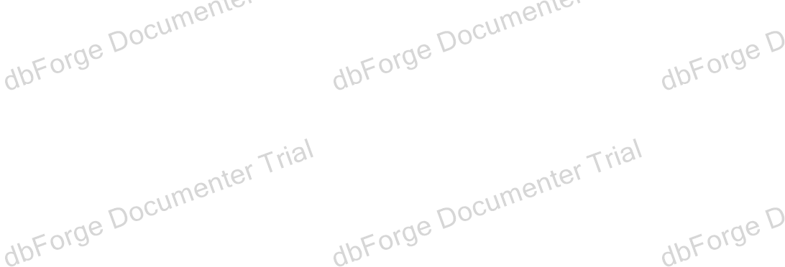

Depends On **1**

ExamSystem

Used By **1**

dbo.Branch_Track_Intake

startDate date NULL, endDate date NULL,

PRIMARY KEY CLUSTERED (Id) ON exam_FG1

)

ON exam_FG1 GO

Project / Servers / . / User databases / ExamSystem / Tables / dbo.Question



# dbo.Question

Description

Properties

|  |  |
| --- | --- |
| **Name** | **Value** |
| File Collation |  |
| File Group | exam_FG2 |
| Filestream File Group |  |
| Is Partitioned | **False** |
| Partitioned Column |  |
| Partition Scheme |  |
| File Groups |  |
| Filestream Partition Scheme |  |
| Filestream File Groups |  |
| Heap | **False** |
| Full Text Catalog |  |
| Full Text |  |
| Compression | NONE |
| Row Count (~) | 21 |
| Created | 1/15/2025 3:31:59 PM |
| Last Modified | 1/15/2025 5:09:26 PM |

Columns **6**

|  |  |  |  |  |  |  |  |  |  |  |  |  |
| --- | --- | --- | --- | --- | --- | --- | --- | --- | --- | --- | --- | --- |
| **Key** | **Name** | **Data Type** | **Length** | **Precision** | **Scale** | **Not Null** | **Identity** | **Rule** | **Default** | **Computed** | **Persisted** | **Description** |
|  | Id | int | 4 | 10 | 0 | **True** | 1 - 1 |  |  | **False** | **False** |  |
|  | Content | varchar | 300 | 0 | 0 | **True** |  |  |  | **False** | **False** |  |
|  | Type | varchar | 40 | 0 | 0 | **True** |  |  |  | **False** | **False** |  |
|  | Correct_Answer | varchar | 50 | 0 | 0 | **True** |  |  |  | **False** | **False** |  |
|  | Ins_Id | int | 4 | 10 | 0 | **False** |  |  |  | **False** | **False** |  |
|  | Crs_Id | int | 4 | 10 | 0 | **False** |  |  |  | **False** | **False** |  |

Indexes **1**

|  |  |  |  |  |  |
| --- | --- | --- | --- | --- | --- |
| **Key** | **Name** | **Columns** | **Unique** | **Type** | **Description** |
|  | PK Question 3214EC07B05727A8 | Id | **True** |  |  |

Triggers **1**



|  |  |  |  |  |  |
| --- | --- | --- | --- | --- | --- |
| **Name** | **ANSI Nulls ON** | **Quoted Identifier ON** | **On** | **Not For Replication** | **Description** |
| trg_instead_of_delete | **True** | **True** | INSTEAD OF DELETE | **False** |  |

Foreign Keys **2**

|  |  |  |  |  |  |
| --- | --- | --- | --- | --- | --- |
| **Name** | | | | **Columns** | **Description** |
| FK | Question | Crs_Id | 4CA06362 | Id |  |
| FK | Question | Ins_Id | 4BAC3F29 | Id |  |

SQL Script

CREATE TABLE dbo.Question ( Id int IDENTITY,

Content varchar(300) NOT NULL, Type varchar(40) NOT NULL,

Correct_Answer varchar(50) NOT NULL, Ins_Id int NULL,

Crs_Id int NULL,

PRIMARY KEY CLUSTERED (Id) ON exam_FG2

)

ON exam_FG2 GO

SET QUOTED_IDENTIFIER, ANSI_NULLS ON GO

CREATE OR ALTER TRIGGER dbo.trg_instead_of_delete ON dbo.Question

INSTEAD OF delete AS

BEGIN

PRINT 'You cannot insert or update any question here';

END; GO

ALTER TABLE dbo.Question WITH NOCHECK

ADD FOREIGN KEY (Crs_Id) REFERENCES dbo.Course (Id) GO

ALTER TABLE dbo.Question WITH NOCHECK

ADD FOREIGN KEY (Ins_Id) REFERENCES dbo.Instructor (Id) GO

Depends On **3**

ExamSystem

dbo.Course dbo.Instructor

Used By **12**

dbo.GetExamQuestionsForStudent dbo.GetStudentIncorrectAnswers dbo.SP_deleteQuestion dbo.sp_insertExamQuestions dbo.sp_insertQuestion dbo.sp_insertStudentQuestionAnswers dbo.sp_selectexamquestion dbo.sp_selectquestionchoices dbo.sp_selectquestions

dbo.answers



dbo.Exam_Questions dbo.Question_Choices

Project / Servers / . / User databases / ExamSystem / Tables / dbo.Question_Choices



# dbo.Question_Choices

Description

Properties

|  |  |
| --- | --- |
| **Name** | **Value** |
| File Collation |  |
| File Group | exam_FG2 |
| Filestream File Group |  |
| Is Partitioned | **False** |
| Partitioned Column |  |
| Partition Scheme |  |
| File Groups |  |
| Filestream Partition Scheme |  |
| Filestream File Groups |  |
| Heap | **False** |
| Full Text Catalog |  |
| Full Text |  |
| Compression | NONE |
| Row Count (~) | 61 |
| Created | 1/15/2025 3:32:02 PM |
| Last Modified | 1/15/2025 3:42:58 PM |

Columns **2**

|  |  |  |  |  |  |  |  |  |  |  |  |  |
| --- | --- | --- | --- | --- | --- | --- | --- | --- | --- | --- | --- | --- |
| **Key** | **Name** | **Data Type** | **Length** | **Precision** | **Scale** | **Not Null** | **Identity** | **Rule** | **Default** | **Computed** | **Persisted** | **Description** |
|  | Quest_Id | int | 4 | 10 | 0 | **True** |  |  |  | **False** | **False** |  |
|  | Choice_Text | varchar | 300 | 0 | 0 | **True** |  |  |  | **False** | **False** |  |

Indexes **1**

|  |  |  |  |  |  |
| --- | --- | --- | --- | --- | --- |
| **Key** | **Name** | **Columns** | **Unique** | **Type** | **Description** |
|  | PK_Choice_Quest | Quest_Id, Choice_Text | **True** |  |  |

Foreign Keys **1**

|  |  |  |
| --- | --- | --- |
| **Name** | **Columns** | **Description** |
| FK Question Quest 4F7CD00D | Id |  |



SQL Script

Depends On **2**

ExamSystem

dbo.Question

Used By **4**

dbo.SP_deleteQuestion dbo.sp_insertQuestion dbo.sp_selectquestionchoices dbo.sp_selectquestions

CREATE TABLE dbo.Question_Choices ( Quest_Id int NOT NULL, Choice_Text varchar(300) NOT NULL,

CONSTRAINT PK_Choice_Quest PRIMARY KEY CLUSTERED (Quest_Id, Choice_Text) ON exam_FG2

)

ON exam_FG2 GO

ALTER TABLE dbo.Question_Choices WITH NOCHECK

ADD FOREIGN KEY (Quest_Id) REFERENCES dbo.Question (Id) ON DELETE CASCADE ON UPDATE CASCADE GO

Project / Servers / . / User databases / ExamSystem / Tables / dbo.Student_Exam



# dbo.Student_Exam

Description

Properties

|  |  |
| --- | --- |
| **Name** | **Value** |
| File Collation |  |
| File Group | exam_FG3 |
| Filestream File Group |  |
| Is Partitioned | **False** |
| Partitioned Column |  |
| Partition Scheme |  |
| File Groups |  |
| Filestream Partition Scheme |  |
| Filestream File Groups |  |
| Heap | **False** |
| Full Text Catalog |  |
| Full Text |  |
| Compression | NONE |
| Row Count (~) | 5 |
| Created | 1/15/2025 3:32:25 PM |
| Last Modified | 1/15/2025 4:51:14 PM |

Columns **3**

|  |  |  |  |  |  |  |  |  |  |  |  |  |
| --- | --- | --- | --- | --- | --- | --- | --- | --- | --- | --- | --- | --- |
| **Key** | **Name** | **Data Type** | **Length** | **Precision** | **Scale** | **Not Null** | **Identity** | **Rule** | **Default** | **Computed** | **Persisted** | **Description** |
|  | Std_Id | int | 4 | 10 | 0 | **True** |  |  |  | **False** | **False** |  |
|  | Exam_Id | int | 4 | 10 | 0 | **True** |  |  |  | **False** | **False** |  |
|  | results | int | 4 | 10 | 0 | **True** |  |  |  | **False** | **False** |  |

Indexes **1**

|  |  |  |  |  |  |
| --- | --- | --- | --- | --- | --- |
| **Key** | **Name** | **Columns** | **Unique** | **Type** | **Description** |
|  | PK_Std_Exam | Std_Id, Exam_Id | **True** |  |  |

Foreign Keys **2**

|  |  |  |
| --- | --- | --- |
| **Name** | **Columns** | **Description** |

|  |  |  |
| --- | --- | --- |
| FK_Std_Exam_Exam | Id |  |
| FK_Std_Exam_Std | Id |  |

SQL Script

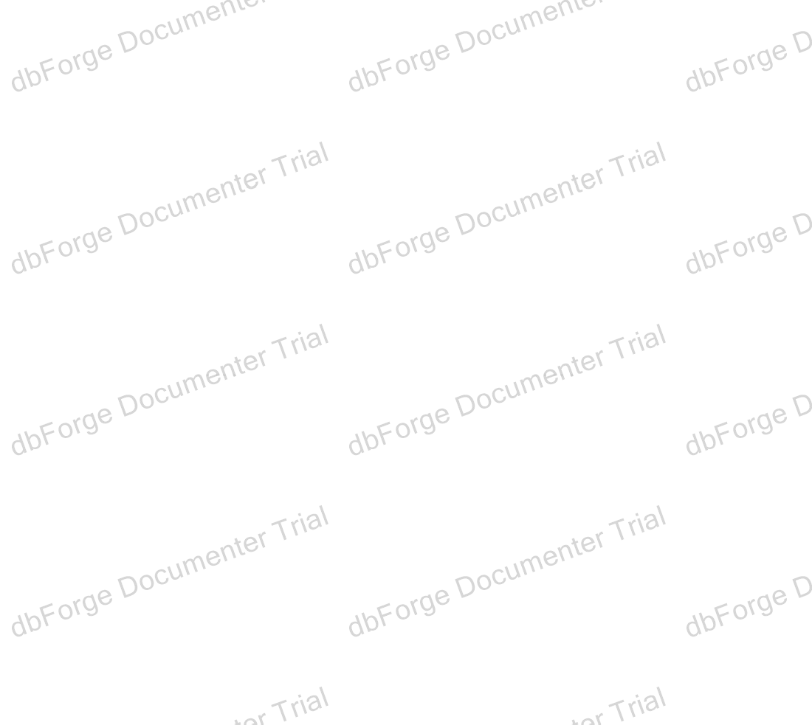

CREATE TABLE dbo.Student_Exam ( Std_Id int NOT NULL,

Exam_Id int NOT NULL, results int NOT NULL,

CONSTRAINT PK_Std_Exam PRIMARY KEY CLUSTERED (Std_Id, Exam_Id) ON exam_FG3

)

ON exam_FG3 GO

ALTER TABLE dbo.Student_Exam

ADD CONSTRAINT FK_Std_Exam_Exam FOREIGN KEY (Exam_Id) REFERENCES dbo.Exam (Id) ON DELETE CASCADE ON UPDATE CASCADE

GO

ALTER TABLE dbo.Student_Exam

ADD CONSTRAINT FK_Std_Exam_Std FOREIGN KEY (Std_Id) REFERENCES std.Student (Id) ON DELETE CASCADE ON UPDATE CASCADE

GO

Depends On **2**

dbo.Exam std.Student

Used By **7**

dbo.GetExamQuestionsForStudent dbo.GetStudentAverageGrade dbo.GetStudentExams dbo.sp_insertStudentExam dbo.sp_insertStudentQuestionAnswers dbo.answers dbo.V_selectStudentExam

Project / Servers / . / User databases / ExamSystem / Tables / dbo.Student_in_Track



# dbo.Student_in_Track

Description

Properties

|  |  |
| --- | --- |
| **Name** | **Value** |
| File Collation |  |
| File Group | exam_FG1 |
| Filestream File Group |  |
| Is Partitioned | **False** |
| Partitioned Column |  |
| Partition Scheme |  |
| File Groups |  |
| Filestream Partition Scheme |  |
| Filestream File Groups |  |
| Heap | **False** |
| Full Text Catalog |  |
| Full Text |  |
| Compression | NONE |
| Row Count (~) | 2 |
| Created | 1/15/2025 3:30:47 PM |
| Last Modified | 1/15/2025 4:54:37 PM |

Columns **2**

|  |  |  |  |  |  |  |  |  |  |  |  |  |
| --- | --- | --- | --- | --- | --- | --- | --- | --- | --- | --- | --- | --- |
| **Key** | **Name** | **Data Type** | **Length** | **Precision** | **Scale** | **Not Null** | **Identity** | **Rule** | **Default** | **Computed** | **Persisted** | **Description** |
|  | Std_Id | int | 4 | 10 | 0 | **True** |  |  |  | **False** | **False** |  |
|  | Track_Id | int | 4 | 10 | 0 | **True** |  |  |  | **False** | **False** |  |

Indexes **1**

|  |  |  |  |  |  |
| --- | --- | --- | --- | --- | --- |
| **Key** | **Name** | **Columns** | **Unique** | **Type** | **Description** |
|  | PK_Std_Trk | Std_Id, Track_Id | **True** |  |  |

Foreign Keys **2**

|  |  |  |
| --- | --- | --- |
| **Name** | **Columns** | **Description** |
| FK_Std_Trk_Std | Id |  |

|  |  |  |
| --- | --- | --- |
| FK_Std_Trk_Trk | Id |  |



SQL Script

Depends On **2**

dbo.Track std.Student

Used By **2**

dbo.RegisterStudentInTrack dbo.StudentCourseNames

CREATE TABLE dbo.Student_in_Track ( Std_Id int NOT NULL,

Track_Id int NOT NULL,

CONSTRAINT PK_Std_Trk PRIMARY KEY CLUSTERED (Std_Id, Track_Id) ON exam_FG1

)

ON exam_FG1 GO

ALTER TABLE dbo.Student_in_Track

ADD CONSTRAINT FK_Std_Trk_Std FOREIGN KEY (Std_Id) REFERENCES std.Student (Id) ON DELETE CASCADE ON UPDATE CASCADE

GO

ALTER TABLE dbo.Student_in_Track

ADD CONSTRAINT FK_Std_Trk_Trk FOREIGN KEY (Track_Id) REFERENCES dbo.Track (Id) ON DELETE CASCADE ON UPDATE CASCADE

GO

Project / Servers / . / User databases / ExamSystem / Tables / dbo.Track



# dbo.Track

Description

Properties

|  |  |
| --- | --- |
| **Name** | **Value** |
| File Collation |  |
| File Group | exam_FG1 |
| Filestream File Group |  |
| Is Partitioned | **False** |
| Partitioned Column |  |
| Partition Scheme |  |
| File Groups |  |
| Filestream Partition Scheme |  |
| Filestream File Groups |  |
| Heap | **False** |
| Full Text Catalog |  |
| Full Text |  |
| Compression | NONE |
| Row Count (~) | 8 |
| Created | 1/15/2025 3:26:46 PM |
| Last Modified | 1/15/2025 5:08:10 PM |

Columns **3**

|  |  |  |  |  |  |  |  |  |  |  |  |  |
| --- | --- | --- | --- | --- | --- | --- | --- | --- | --- | --- | --- | --- |
| **Key** | **Name** | **Data Type** | **Length** | **Precision** | **Scale** | **Not Null** | **Identity** | **Rule** | **Default** | **Computed** | **Persisted** | **Description** |
|  | Id | int | 4 | 10 | 0 | **True** | 1 - 1 |  |  | **False** | **False** |  |
|  | Name | varchar | 70 | 0 | 0 | **False** |  |  |  | **False** | **False** |  |
|  | Dept_Id | int | 4 | 10 | 0 | **False** |  |  |  | **False** | **False** |  |

Indexes **1**

|  |  |  |  |  |  |
| --- | --- | --- | --- | --- | --- |
| **Key** | **Name** | **Columns** | **Unique** | **Type** | **Description** |
|  | PK Track 3214EC0712D9B425 | Id | **True** |  |  |

Triggers **1**

|  |  |  |  |  |  |
| --- | --- | --- | --- | --- | --- |
| **Name** | **ANSI**  **Nulls ON** | **Quoted Identifier ON** | **On** | **Not For Replication** | **Description** |

|  |  |  |  |  |  |
| --- | --- | --- | --- | --- | --- |
| after_insert_delete_update_trg | **True** | **True** | AFTER INSERT, UPDATE, DELETE | **False** |  |

Foreign Keys **1**



|  |  |  |
| --- | --- | --- |
| **Name** | **Columns** | **Description** |
| FK Track Dept_Id 2A4B4B5E | Id |  |

SQL Script

CREATE TABLE dbo.Track ( Id int IDENTITY,

Name varchar(70) NULL, Dept_Id int NULL,

PRIMARY KEY CLUSTERED (Id) ON exam_FG1

)

ON exam_FG1 GO

SET QUOTED_IDENTIFIER, ANSI_NULLS ON GO

create or alter trigger dbo.after_insert_delete_update_trg on dbo.Track

after delete, update , insert as

Begin

declare @newtrack_name nvarchar(30) declare @track_name nvarchar(30) declare @track_id int

select @track_name =(select [name] from deleted) select @newtrack_name=(select [name] from inserted) select @track_id =(select id from inserted)

insert into audit_track_insert_update_delete(trake_id,track_name,track_date,tuser_name,new_track_name) values(@track_id,@track_name,GETDATE(),SUSER_NAME(),@newtrack_name)

select*from inserted select*from deleted End

GO

ALTER TABLE dbo.Track

ADD FOREIGN KEY (Dept_Id) REFERENCES dbo.Department (Id) GO

Depends On **2**

ExamSystem

dbo.Department

Used By **3**

dbo.Branch_Track_Intake dbo.Courses_in_Track dbo.Student_in_Track

Project / Servers / . / User databases / ExamSystem / Tables / dbo.training_manager



# dbo.training_manager

Description

Properties

|  |  |
| --- | --- |
| **Name** | **Value** |
| File Collation |  |
| File Group | exam_FG1 |
| Filestream File Group |  |
| Is Partitioned | **False** |
| Partitioned Column |  |
| Partition Scheme |  |
| File Groups |  |
| Filestream Partition Scheme |  |
| Filestream File Groups |  |
| Heap | **False** |
| Full Text Catalog |  |
| Full Text |  |
| Compression | NONE |
| Row Count (~) | 5 |
| Created | 1/15/2025 3:26:46 PM |
| Last Modified | 1/15/2025 3:29:56 PM |

Columns **3**

|  |  |  |  |  |  |  |  |  |  |  |  |  |
| --- | --- | --- | --- | --- | --- | --- | --- | --- | --- | --- | --- | --- |
| **Key** | **Name** | **Data Type** | **Length** | **Precision** | **Scale** | **Not Null** | **Identity** | **Rule** | **Default** | **Computed** | **Persisted** | **Description** |
|  | manager_id | int | 4 | 10 | 0 | **True** |  |  |  | **False** | **False** |  |
|  | name | varchar | 20 | 0 | 0 | **False** |  |  |  | **False** | **False** |  |
|  | phone | varchar | 11 | 0 | 0 | **False** |  |  |  | **False** | **False** |  |

Indexes **1**

|  |  |  |  |  |  |
| --- | --- | --- | --- | --- | --- |
| **Key** | **Name** | **Columns** | **Unique** | **Type** | **Description** |
|  | PK training 5A6073FC80A91C40 | manager_id | **True** |  |  |

SQL Script

CREATE TABLE dbo.training_manager ( manager_id int NOT NULL,

name varchar(20) NULL, phone varchar(11) NULL,

PRIMARY KEY CLUSTERED (manager_id) ON exam_FG1



Depends On **1**

ExamSystem

Used By **2**

dbo.sp_getbranchdetails dbo.Branch

)

ON exam_FG1 GO

Project / Servers / . / User databases / ExamSystem / Tables / std.Student



# std.Student

Description

Properties

|  |  |
| --- | --- |
| **Name** | **Value** |
| File Collation |  |
| File Group |  |
| Filestream File Group |  |
| Is Partitioned | **False** |
| Partitioned Column |  |
| Partition Scheme |  |
| File Groups |  |
| Filestream Partition Scheme |  |
| Filestream File Groups |  |
| Heap | **False** |
| Full Text Catalog |  |
| Full Text |  |
| Compression | NONE |
| Row Count (~) | 5 |
| Created | 1/15/2025 3:30:24 PM |
| Last Modified | 1/15/2025 4:54:37 PM |

Columns **9**

|  |  |  |  |  |  |  |  |  |  |  |  |  |
| --- | --- | --- | --- | --- | --- | --- | --- | --- | --- | --- | --- | --- |
| **Key** | **Name** | **Data Type** | **Length** | **Precision** | **Scale** | **Not Null** | **Identity** | **Rule** | **Default** | **Computed** | **Persisted** | **Description** |
|  | Id | int | 4 | 10 | 0 | **True** | 1 - 1 |  |  | **False** | **False** |  |
|  | Fname | varchar | 15 | 0 | 0 | **False** |  |  |  | **False** | **False** |  |
|  | Lname | varchar | 15 | 0 | 0 | **False** |  |  |  | **False** | **False** |  |
|  | Phone | varchar | 11 | 0 | 0 | **False** |  |  |  | **False** | **False** |  |
|  | BirthDate | date | 3 | 10 | 0 | **False** |  |  |  | **False** | **False** |  |
|  | City | varchar | 25 | 0 | 0 | **False** |  |  |  | **False** | **False** |  |
|  | Street | varchar | 50 | 0 | 0 | **False** |  |  |  | **False** | **False** |  |
|  | Email | varchar | 100 | 0 | 0 | **False** |  |  |  | **False** | **False** |  |
|  | Class_Id | int | 4 | 10 | 0 | **False** |  |  |  | **False** | **False** |  |

Indexes **1**

|  |  |  |  |  |  |
| --- | --- | --- | --- | --- | --- |
| **Key** | **Name** | **Columns** | **Unique** | **Type** | **Description** |

|  |  |  |  |  |  |
| --- | --- | --- | --- | --- | --- |
|  | PK Student 3214EC0717ABDBC1 | Id | **True** |  |  |

SQL Script

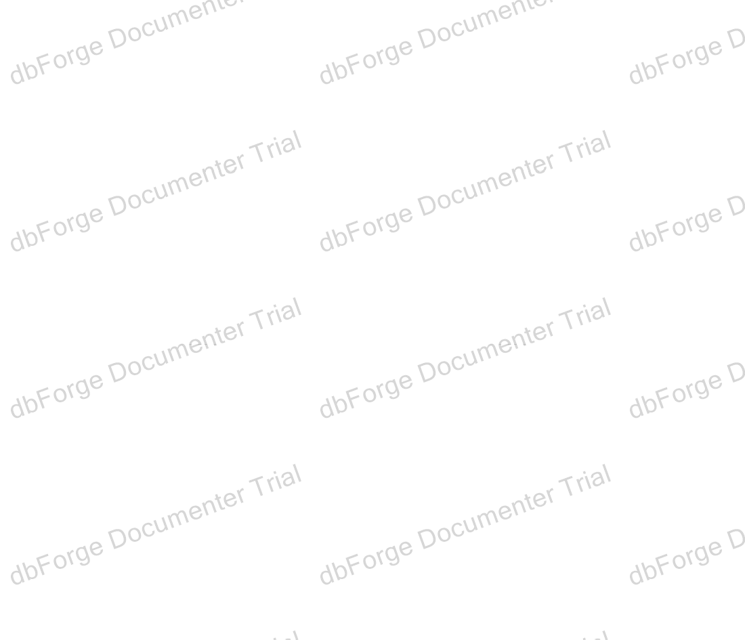

CREATE TABLE std.Student ( Id int IDENTITY,

Fname varchar(15) NULL, Lname varchar(15) NULL, Phone varchar(11) NULL, BirthDate date NULL, City varchar(25) NULL, Street varchar(50) NULL, Email varchar(100) NULL, Class_Id int NULL,

PRIMARY KEY CLUSTERED (Id)

)

ON [PRIMARY] GO

Depends On **2**

ExamSystem

std

Used By **9**

dbo.GetExamQuestionsForStudent dbo.GetStudentAverageGrade dbo.Student_AllCoursesResult dbo.answers dbo.Courses_in_Track dbo.Student_Exam dbo.Student_in_Track dbo.StudentCourseNames dbo.V_selectStudentExam

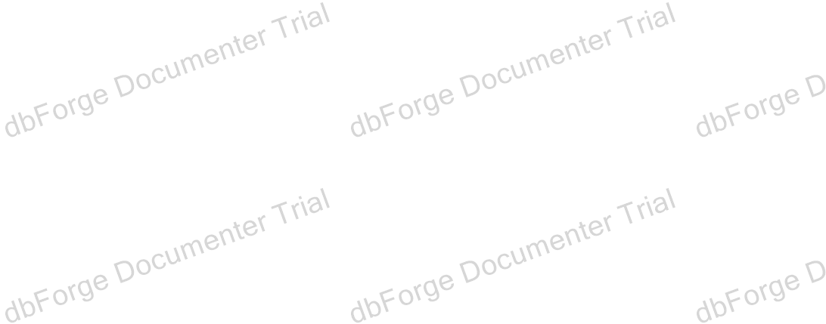

Project / Servers / . / User databases / ExamSystem / Views

Views

Objects **5**

|  |  |
| --- | --- |
| **Name** | **Description** |
| dbo.showAllInstructor_V |  |
| dbo.StudentCourseNames |  |
| dbo.V_selectExamsInCourse |  |
| dbo.V_selectStudentExam |  |
| dbo.view_all_courses |  |

Project / Servers / . / User databases / ExamSystem / Views / dbo.showAllInstructor_V



# dbo.showAllInstructor_V

Description

Properties

|  |  |
| --- | --- |
| **Name** | **Value** |
| Collation | SQL_Latin1_General_CP1_CI_AS |
| ANSI Nulls ON | **True** |
| Quoted Identifier ON | **True** |
| Encrypted | **False** |
| Schema Bound | **False** |
| Created | 1/15/2025 4:59:15 PM |
| Last Modified | 1/15/2025 4:59:15 PM |

Columns **10**

|  |  |  |
| --- | --- | --- |
| **Key** | **Name** | **Description** |
|  | Id |  |
|  | Fname |  |
|  | Lname |  |
|  | Phone |  |
|  | BirthDate |  |
|  | City |  |
|  | Street |  |
|  | Email |  |
|  | Salary |  |
|  | Class_Id |  |

SQL Script

SET QUOTED_IDENTIFIER, ANSI_NULLS ON GO

‐‐‐‐‐‐‐‐‐‐‐‐‐‐‐‐‐‐‐‐‐‐‐‐‐‐‐‐‐‐‐‐‐‐‐‐‐‐‐‐‐‐‐‐‐‐‐‐‐‐‐‐‐‐‐‐‐‐‐‐‐‐‐‐‐‐‐‐‐‐‐‐‐‐‐‐‐‐‐‐‐‐‐‐‐‐‐‐‐‐‐‐‐‐‐‐‐‐‐‐‐‐‐‐‐‐‐‐ create OR ALTER view dbo.showAllInstructor_V

as

select * from Instructor GO

Depends On **1**

dbo.Instructor

Used By

No items found

Project / Servers / . / User databases / ExamSystem / Views / dbo.StudentCourseNames



# dbo.StudentCourseNames

Description

Properties

|  |  |
| --- | --- |
| **Name** | **Value** |
| Collation | SQL_Latin1_General_CP1_CI_AS |
| ANSI Nulls ON | **True** |
| Quoted Identifier ON | **True** |
| Encrypted | **False** |
| Schema Bound | **False** |
| Created | 1/15/2025 5:00:14 PM |
| Last Modified | 1/15/2025 5:00:14 PM |

Columns **4**

|  |  |  |
| --- | --- | --- |
| **Key** | **Name** | **Description** |
|  | StudentId |  |
|  | StudentName |  |
|  | CourseId |  |
|  | CourseName |  |

SQL Script

SET QUOTED_IDENTIFIER, ANSI_NULLS ON GO

CREATE OR ALTER VIEW dbo.StudentCourseNames AS SELECT

S.Id AS StudentId,

S.Fname+' '+S.Lname AS StudentName, C.Id AS CourseId,

C.Name AS CourseName FROM

std.Student S INNER JOIN

Student_in_Track SIT ON S.Id = Std_Id INNER JOIN

Courses_in_Track CIT ON SIT.Track_Id = CIT.Track_Id INNER JOIN

Course C ON CIT.Crs_Id = C.Id;

GO

Depends On **4**

dbo.Course dbo.Courses_in_Track dbo.Student_in_Track std.Student

Used By

No items found



Project / Servers / . / User databases / ExamSystem / Views / dbo.V_selectExamsInCourse



# dbo.V_selectExamsInCourse

Description

Properties

|  |  |
| --- | --- |
| **Name** | **Value** |
| Collation | SQL_Latin1_General_CP1_CI_AS |
| ANSI Nulls ON | **True** |
| Quoted Identifier ON | **True** |
| Encrypted | **False** |
| Schema Bound | **False** |
| Created | 1/15/2025 4:58:19 PM |
| Last Modified | 1/15/2025 4:58:19 PM |

Columns **10**

|  |  |  |
| --- | --- | --- |
| **Key** | **Name** | **Description** |
|  | course_id |  |
|  | course_name |  |
|  | course_max_degree |  |
|  | course_min_degree |  |
|  | exam_id |  |
|  | exam_year |  |
|  | exam_type |  |
|  | exam_start_time |  |
|  | exam_end_time |  |
|  | exam_total_degree |  |

SQL Script

SET QUOTED_IDENTIFIER, ANSI_NULLS ON GO

create OR ALTER view dbo.V_selectExamsInCourse as

select

c.id as course_id, c.[name] as course_name,

c.max_degree as course_max_degree,c.min_degree as course_min_degree, e.id as exam_id, e.[year] as exam_year,e.[type] as exam_type,

e.start_time as exam_start_time,e.end_time as exam_end_time, e.total_degree as exam_total_degree

from course c inner join

exam e on c.id = e.crs_id

GO

Depends On **2**

dbo.Course



dbo.Exam

Used By

No items found

Project / Servers / . / User databases / ExamSystem / Views / dbo.V_selectStudentExam



# dbo.V_selectStudentExam

Description

Properties

|  |  |
| --- | --- |
| **Name** | **Value** |
| Collation | SQL_Latin1_General_CP1_CI_AS |
| ANSI Nulls ON | **True** |
| Quoted Identifier ON | **True** |
| Encrypted | **False** |
| Schema Bound | **False** |
| Created | 1/15/2025 5:01:14 PM |
| Last Modified | 1/15/2025 5:01:14 PM |

Columns **10**

|  |  |  |
| --- | --- | --- |
| **Key** | **Name** | **Description** |
|  | student_id |  |
|  | first_name |  |
|  | last_name |  |
|  | email |  |
|  | exam_id |  |
|  | exam_year |  |
|  | exam_type |  |
|  | total_time |  |
|  | total_degree |  |
|  | results |  |

SQL Script

SET QUOTED_IDENTIFIER, ANSI_NULLS ON GO

create OR ALTER view dbo.V_selectStudentExam as

select

s.id as student_id,s.fname as first_name,s.lname as last_name, s.email as email, e.id as exam_id, e.[year] as exam_year,

e.[type] as exam_type, e.total_time as total_time, e.total_degree as total_degree,se.results as results

from student_exam se inner join

std.student s on se.std_id = s.id inner join

exam e on se.exam_id = e.id; GO

Depends On **3**



dbo.Exam

dbo.Student_Exam std.Student

Used By

No items found

Project / Servers / . / User databases / ExamSystem / Views / dbo.view_all_courses



# dbo.view_all_courses

Description

Properties

|  |  |
| --- | --- |
| **Name** | **Value** |
| Collation | SQL_Latin1_General_CP1_CI_AS |
| ANSI Nulls ON | **True** |
| Quoted Identifier ON | **True** |
| Encrypted | **False** |
| Schema Bound | **False** |
| Created | 1/15/2025 4:59:29 PM |
| Last Modified | 1/15/2025 4:59:29 PM |

Columns **5**

|  |  |  |
| --- | --- | --- |
| **Key** | **Name** | **Description** |
|  | id |  |
|  | name |  |
|  | description |  |
|  | Max_Degree |  |
|  | Min_Degree |  |

SQL Script

SET QUOTED_IDENTIFIER, ANSI_NULLS ON GO

CREATE OR ALTER View dbo.view_all_courses AS

SELECT

[id], [name], [description], [Max_Degree],[Min_Degree] FROM [course];

GO

Depends On **1**

dbo.Course

Used By

No items found



Project / Servers / . / User databases / ExamSystem / Programmability

Programmability

Objects **2**

Stored Procedures Types

Project / Servers / . / User databases / ExamSystem / Programmability / Stored Procedures



# Stored Procedures

Objects **22**

|  |  |
| --- | --- |
| **Name** | **Description** |
| dbo.AddInstructor |  |
| dbo.AddInstructor_Cource |  |
| dbo.GetExamQuestionsForStudent |  |
| dbo.GetStudentAverageGrade |  |
| dbo.GetStudentExams |  |
| dbo.GetStudentIncorrectAnswers |  |
| dbo.newmanager_proc |  |
| dbo.RegisterStudentInTrack |  |
| dbo.showAllInstructorById |  |
| dbo.SP_deleteExam |  |
| dbo.SP_deleteExamQuestions |  |
| dbo.SP_deleteQuestion |  |
| dbo.sp_getbranchdetails |  |
| dbo.sp_insertExamQuestions |  |
| dbo.sp_insertQuestion |  |
| dbo.sp_insertStudentExam |  |
| dbo.sp_insertStudentQuestionAnswers |  |
| dbo.sp_selectexam |  |
| dbo.sp_selectexamquestion |  |
| dbo.sp_selectquestionchoices |  |
| dbo.sp_selectquestions |  |
| dbo.Student_AllCoursesResult |  |

Project / Servers / . / User databases / ExamSystem / Programmability / Stored Procedures / dbo.AddInstructor



# dbo.AddInstructor

Description

Properties

|  |  |
| --- | --- |
| **Name** | **Value** |
| ANSI Nulls ON | **True** |
| Quoted Identifier ON | **True** |
| Encrypted | **False** |
| Execute As |  |
| Assembly |  |

Parameters **9**

|  |  |  |  |
| --- | --- | --- | --- |
| **Name** | **Data Type** | **Length** | **Description** |
| @Fname | varchar | 15 |  |
| @Lname | varchar | 15 |  |
| @Phone | varchar | 11 |  |
| @BirthDate | date | 3 |  |
| @City | varchar | 25 |  |
| @Street | varchar | 50 |  |
| @Email | varchar | 100 |  |
| @Salary | int | 4 |  |
| @Class_Id | int | 4 |  |

SQL Script

SET QUOTED_IDENTIFIER, ANSI_NULLS ON GO

create OR ALTER proc dbo.AddInstructor (

@Fname varchar(15), @Lname varchar(15), @Phone varchar(11) , @BirthDate Date, @City varchar(25), @Street varchar(50), @Email varchar(100), @Salary int , @Class_Id int )

as begin

insert into Instructor (

Fname , Lname , Phone , BirthDate , City , Street , Email , Salary , Class_Id )

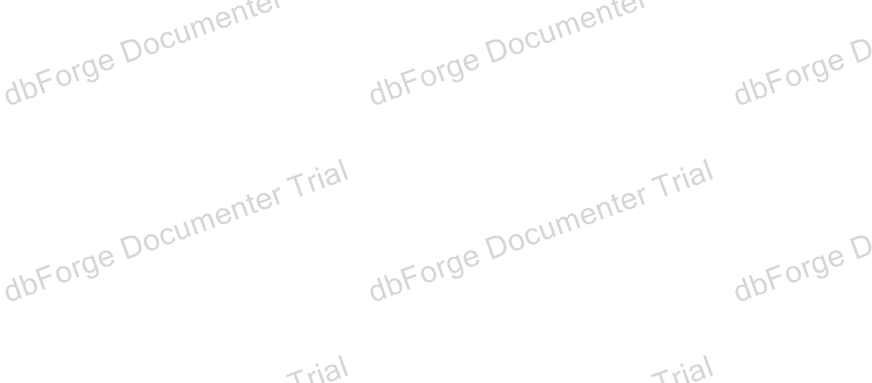

Depends On **1**

dbo.Instructor

Used By

No items found

values ( @Fname , @Lname , @Phone , @BirthDate , @City , @Street , @Email , @Salary , @Class_Id ) end

GO

Project / Servers / . / User databases / ExamSystem / Programmability / Stored Procedures / dbo.AddInstructor_Cource



# dbo.AddInstructor_Cource

Description

Properties

|  |  |
| --- | --- |
| **Name** | **Value** |
| ANSI Nulls ON | **True** |
| Quoted Identifier ON | **True** |
| Encrypted | **False** |
| Execute As |  |
| Assembly |  |

Parameters **4**

|  |  |  |  |
| --- | --- | --- | --- |
| **Name** | **Data Type** | **Length** | **Description** |
| @Ins_Id | int | 4 |  |
| @Crs_Id | int | 4 |  |
| @Class_Id | int | 4 |  |
| @yearOfInstructor | int | 4 |  |

SQL Script

SET QUOTED_IDENTIFIER, ANSI_NULLS ON GO

create OR ALTER proc dbo.AddInstructor_Cource (

@Ins_Id int , @Crs_Id int , @Class_Id int,

@yearOfInstructor int ) as

begin

insert into Instructor_Course (

Ins_Id , Crs_Id , Class_Id ,

yearOfInstructor ) values (

@Ins_Id , @Crs_Id , @Class_Id ,

@yearOfInstructor ) end

GO

Depends On **1**

dbo.Instructor_Course

Used By

No items found

Project / Servers / . / User databases / ExamSystem / Programmability / Stored Procedures / dbo.GetExamQuestionsForStudent



# dbo.GetExamQuestionsForStudent

Description

Properties

|  |  |
| --- | --- |
| **Name** | **Value** |
| ANSI Nulls ON | **True** |
| Quoted Identifier ON | **True** |
| Encrypted | **False** |
| Execute As |  |
| Assembly |  |

Parameters **2**

|  |  |  |  |
| --- | --- | --- | --- |
| **Name** | **Data Type** | **Length** | **Description** |
| @StudentId | int | 4 |  |
| @ExamId | int | 4 |  |

SQL Script

SET QUOTED_IDENTIFIER, ANSI_NULLS ON GO

CREATE OR ALTER PROCEDURE dbo.GetExamQuestionsForStudent @StudentId INT,

@ExamId INT

AS BEGIN

SELECT

CONCAT(S.Fname,' ' , S.Lname) AS StudentName, Q.Id AS QuestionId,

Q.Content AS QuestionContent, Q.Type AS QuestionType

FROM

Student_Exam SE INNER JOIN

std.Student S ON SE.Std_id = S.Id INNER JOIN

Exam_Questions EQ ON SE.Exam_id = EQ.Exam_id INNER JOIN

Question Q ON EQ.Quest_Id = Q.Id WHERE

SE.Std_id = @StudentId AND SE.Exam_id = @ExamId;

END; GO

Depends On **4**

dbo.Exam_Questions dbo.Question dbo.Student_Exam std.Student

Used By

No items found



Project / Servers / . / User databases / ExamSystem / Programmability / Stored Procedures / dbo.GetStudentAverageGrade



# dbo.GetStudentAverageGrade

Description

Properties

|  |  |
| --- | --- |
| **Name** | **Value** |
| ANSI Nulls ON | **True** |
| Quoted Identifier ON | **True** |
| Encrypted | **False** |
| Execute As |  |
| Assembly |  |

Parameters **1**

|  |  |  |  |
| --- | --- | --- | --- |
| **Name** | **Data Type** | **Length** | **Description** |
| @StudentId | int | 4 |  |

SQL Script

SET QUOTED_IDENTIFIER, ANSI_NULLS ON GO

CREATE OR ALTER PROCEDURE dbo.GetStudentAverageGrade @StudentId INT

AS BEGIN

SELECT

S.Fname AS StudentName, AVG(SE.results) AS AverageGrade

FROM

Student_Exam SE INNER JOIN

std.Student S ON SE.Std_id = S.Id WHERE

SE.Std_id = @StudentId GROUP BY

S.Fname

END; GO

Depends On **2**

dbo.Student_Exam std.Student

Used By

No items found

Project / Servers / . / User databases / ExamSystem / Programmability / Stored Procedures / dbo.GetStudentExams



# dbo.GetStudentExams

Description

Properties

|  |  |
| --- | --- |
| **Name** | **Value** |
| ANSI Nulls ON | **True** |
| Quoted Identifier ON | **True** |
| Encrypted | **False** |
| Execute As |  |
| Assembly |  |

Parameters **1**

|  |  |  |  |
| --- | --- | --- | --- |
| **Name** | **Data Type** | **Length** | **Description** |
| @StudentId | int | 4 |  |

SQL Script

SET QUOTED_IDENTIFIER, ANSI_NULLS ON GO

CREATE OR ALTER PROCEDURE dbo.GetStudentExams @StudentId INT AS

BEGIN

SELECT

E.Id AS ExamId, E.Year,

E.Type AS ExamType, E.Total_Degree,

SE.results AS StudentResult FROM

Student_Exam SE INNER JOIN

Exam E ON SE.Exam_id = E.Id WHERE

SE.Std_id = @StudentId;

END; GO

Depends On **2**

dbo.Exam dbo.Student_Exam

Used By

No items found

Project / Servers / . / User databases / ExamSystem / Programmability / Stored Procedures / dbo.GetStudentIncorrectAnswers



# dbo.GetStudentIncorrectAnswers

Description

Properties

|  |  |
| --- | --- |
| **Name** | **Value** |
| ANSI Nulls ON | **True** |
| Quoted Identifier ON | **True** |
| Encrypted | **False** |
| Execute As |  |
| Assembly |  |

Parameters **2**

|  |  |  |  |
| --- | --- | --- | --- |
| **Name** | **Data Type** | **Length** | **Description** |
| @StudentId | int | 4 |  |
| @QId | int | 4 |  |

SQL Script

SET QUOTED_IDENTIFIER, ANSI_NULLS ON GO

CREATE OR ALTER PROCEDURE dbo.GetStudentIncorrectAnswers @StudentId INT,

@QId INT

AS BEGIN

SELECT

Q.Content AS QuestionContent, A.Answer_Text AS StudentAnswer, Q.Correct_Answer AS CorrectAnswer

FROM

Answers A INNER JOIN

Question Q ON A.Quest_Id = Q.Id WHERE

A.Std_id = @StudentId AND A.Quest_Id = @QId AND A.Is_Correct = 0;

END; GO

Depends On **2**

dbo.answers dbo.Question

Used By

No items found

Project / Servers / . / User databases / ExamSystem / Programmability / Stored Procedures / dbo.newmanager_proc



# dbo.newmanager_proc

Description

Properties

|  |  |
| --- | --- |
| **Name** | **Value** |
| ANSI Nulls ON | **True** |
| Quoted Identifier ON | **True** |
| Encrypted | **False** |
| Execute As |  |
| Assembly |  |

Parameters **3**

|  |  |  |  |
| --- | --- | --- | --- |
| **Name** | **Data Type** | **Length** | **Description** |
| @oldmananagernum | int | 4 |  |
| @newmananagernum | int | 4 |  |
| @branchNum | int | 4 |  |

SQL Script

SET QUOTED_IDENTIFIER, ANSI_NULLS ON GO

create OR ALTER procedure dbo.newmanager_proc @oldmananagernum int ,

@newmananagernum int , @branchNum int

as begin

if Exists (

select 1 from Branch

where manager_id = @oldmananagernum and Id = @branchNum

)

begin

update Branch ‐‐to replace old b new set manager_id = @newmananagernum

where manager_id = @oldmananagernum and Id = @branchNum;

print 'new employee has been replaced' end

else begin

print 'there no records found ' end

End; GO

Depends On **1**

dbo.Branch

Used By

No items found

Project / Servers / . / User databases / ExamSystem / Programmability / Stored Procedures / dbo.RegisterStudentInTrack



# dbo.RegisterStudentInTrack

Description

Properties

|  |  |
| --- | --- |
| **Name** | **Value** |
| ANSI Nulls ON | **True** |
| Quoted Identifier ON | **True** |
| Encrypted | **False** |
| Execute As |  |
| Assembly |  |

Parameters **2**

|  |  |  |  |
| --- | --- | --- | --- |
| **Name** | **Data Type** | **Length** | **Description** |
| @StudentId | int | 4 |  |
| @TrackId | int | 4 |  |

SQL Script

SET QUOTED_IDENTIFIER, ANSI_NULLS ON GO

CREATE OR ALTER PROCEDURE dbo.RegisterStudentInTrack @StudentId INT,

@TrackId INT

AS BEGIN

INSERT INTO Student_in_Track (Std_Id, Track_Id) VALUES (@StudentId, @TrackId);

END GO

Depends On **1**

dbo.Student_in_Track

Used By

No items found

Project / Servers / . / User databases / ExamSystem / Programmability / Stored Procedures / dbo.showAllInstructorById



# dbo.showAllInstructorById

Description

Properties

|  |  |
| --- | --- |
| **Name** | **Value** |
| ANSI Nulls ON | **True** |
| Quoted Identifier ON | **True** |
| Encrypted | **False** |
| Execute As |  |
| Assembly |  |

Parameters **1**

|  |  |  |  |
| --- | --- | --- | --- |
| **Name** | **Data Type** | **Length** | **Description** |
| @id | int | 4 |  |

SQL Script

SET QUOTED_IDENTIFIER, ANSI_NULLS ON GO

create OR ALTER proc dbo.showAllInstructorById @id int as

begin

select * from Instructor where Id = @id

end GO

Depends On **1**

dbo.Instructor

Used By

No items found

Project / Servers / . / User databases / ExamSystem / Programmability / Stored Procedures / dbo.SP_deleteExam



# dbo.SP_deleteExam

Description

Properties

|  |  |
| --- | --- |
| **Name** | **Value** |
| ANSI Nulls ON | **True** |
| Quoted Identifier ON | **True** |
| Encrypted | **False** |
| Execute As |  |
| Assembly |  |

Parameters **1**

|  |  |  |  |
| --- | --- | --- | --- |
| **Name** | **Data Type** | **Length** | **Description** |
| @examID | int | 4 |  |

SQL Script

SET QUOTED_IDENTIFIER, ANSI_NULLS ON GO

create OR ALTER proc dbo.SP_deleteExam (@examID int) as

begin

IF EXISTS(SELECT 1 FROM Exam WHERE id=@examId)

begin

delete from Exam_questions where Exam_Id=@examID delete from Exam where id=@examID

end else begin

print'This exam doesnot exist' end

end GO

Depends On **2**

dbo.Exam dbo.Exam_Questions

Used By

No items found

Project / Servers / . / User databases / ExamSystem / Programmability / Stored Procedures / dbo.SP_deleteExamQuestions



# dbo.SP_deleteExamQuestions

Description

Properties

|  |  |
| --- | --- |
| **Name** | **Value** |
| ANSI Nulls ON | **True** |
| Quoted Identifier ON | **True** |
| Encrypted | **False** |
| Execute As |  |
| Assembly |  |

Parameters **2**

|  |  |  |  |
| --- | --- | --- | --- |
| **Name** | **Data Type** | **Length** | **Description** |
| @examID | int | 4 |  |
| @QuestionId | int | 4 |  |

SQL Script

SET QUOTED_IDENTIFIER, ANSI_NULLS ON GO

create OR ALTER proc dbo.SP_deleteExamQuestions(@examID int,@QuestionId int) as

begin

IF EXISTS(SELECT 1 FROM Exam_questions WHERE Exam_Id=@examID and Quest_Id=@questionid) begin

delete from Exam_questions where Exam_Id=@examID and Quest_Id=@QuestionId end

else begin

print 'This question of this exam doesnot exist' end

end GO

Depends On **1**

dbo.Exam_Questions

Used By

No items found

Project / Servers / . / User databases / ExamSystem / Programmability / Stored Procedures / dbo.SP_deleteQuestion



# dbo.SP_deleteQuestion

Description

Properties

|  |  |
| --- | --- |
| **Name** | **Value** |
| ANSI Nulls ON | **True** |
| Quoted Identifier ON | **True** |
| Encrypted | **False** |
| Execute As |  |
| Assembly |  |

Parameters **1**

|  |  |  |  |
| --- | --- | --- | --- |
| **Name** | **Data Type** | **Length** | **Description** |
| @questionID | int | 4 |  |

SQL Script

SET QUOTED_IDENTIFIER, ANSI_NULLS ON GO

create OR ALTER proc dbo.SP_deleteQuestion(@questionID int) as

begin

IF Exists(select 1 from Question where id=@questionId) begin

delete from Exam_questions where Quest_Id=@questionID delete from Question_Choices where Quest_Id=@questionId delete from Question where id=@questionID

end else begin

select'This Question doesnot in Data' end

end GO

Depends On **3**

dbo.Exam_Questions dbo.Question dbo.Question_Choices

Used By

No items found

Project / Servers / . / User databases / ExamSystem / Programmability / Stored Procedures / dbo.sp_getbranchdetails



# dbo.sp_getbranchdetails

Description

Properties

|  |  |
| --- | --- |
| **Name** | **Value** |
| ANSI Nulls ON | **True** |
| Quoted Identifier ON | **True** |
| Encrypted | **True** |
| Execute As |  |
| Assembly |  |

Parameters **4**

|  |  |  |  |
| --- | --- | --- | --- |
| **Name** | **Data Type** | **Length** | **Description** |
| @id | int | 4 |  |
| @name | varchar | -1 |  |
| @location | varchar | 50 |  |
| @managername | varchar | -1 |  |

SQL Script

SET QUOTED_IDENTIFIER, ANSI_NULLS ON GO

create OR ALTER proc dbo.sp_getbranchdetails @id int , @name varchar(max) output , @location varchar(50) output

,@managername varchar(max) output with encryption

AS

select @id=b.Id, @name=B.[Name],@location=B.[location] ,@managername=M.[name] from Branch B , training_manager M

where B.manager_id = M.manager_id and B.Id = @id

GO

Depends On **2**

dbo.Branch dbo.training_manager

Used By

No items found

Project / Servers / . / User databases / ExamSystem / Programmability / Stored Procedures / dbo.sp_insertExamQuestions



# dbo.sp_insertExamQuestions

Description

Properties

|  |  |
| --- | --- |
| **Name** | **Value** |
| ANSI Nulls ON | **True** |
| Quoted Identifier ON | **True** |
| Encrypted | **False** |
| Execute As |  |
| Assembly |  |

Parameters **3**

|  |  |  |  |
| --- | --- | --- | --- |
| **Name** | **Data Type** | **Length** | **Description** |
| @exam_id | int | 4 |  |
| @quest_id | int | 4 |  |
| @quest_degree | int | 4 |  |

SQL Script

SET QUOTED_IDENTIFIER, ANSI_NULLS ON GO

create OR ALTER procedure dbo.sp_insertExamQuestions(@exam_id int,@quest_id int,@quest_degree int) as

begin

if exists (select 1 from exam_questions where exam_id = @exam_id and quest_id = @quest_id) begin

print 'the question already exists in this exam.'; return

end

if not exists (select 1 from exam where id = @exam_id) begin

print 'invalid exam_id.'; return

end

if not exists (select 1 from question where id = @quest_id) begin

print 'invalid quest_id.'; return

end

insert into exam_questions (exam_id, quest_id, quest_degree) values (@exam_id, @quest_id, @quest_degree);

print 'question inserted successfully in the exam.';

end GO

Depends On **3**

dbo.Exam dbo.Exam_Questions dbo.Question



Used By

No items found

Project / Servers / . / User databases / ExamSystem / Programmability / Stored Procedures / dbo.sp_insertQuestion



# dbo.sp_insertQuestion

Description

Properties

|  |  |
| --- | --- |
| **Name** | **Value** |
| ANSI Nulls ON | **True** |
| Quoted Identifier ON | **True** |
| Encrypted | **False** |
| Execute As |  |
| Assembly |  |

Parameters **6**

|  |  |  |  |
| --- | --- | --- | --- |
| **Name** | **Data Type** | **Length** | **Description** |
| @content | varchar | 300 |  |
| @type | varchar | 40 |  |
| @correct_answer | varchar | 50 |  |
| @ins_id | int | 4 |  |
| @crs_id | int | 4 |  |
| @choices | choicetype | max |  |

SQL Script

SET QUOTED_IDENTIFIER, ANSI_NULLS ON GO

create OR ALTER procedure dbo.sp_insertQuestion (@content varchar(300),@type varchar(40), @correct_answer varchar(50),

@ins_id int,@crs_id int,@choices dbo.choicetype readonly )

as begin

declare @quest_id int;

insert into question (content, [type], correct_answer, ins_id, crs_id) values (@content, @type, @correct_answer, @ins_id, @crs_id);

set @quest_id = scope_identity(); if @quest_id is null

begin

print('failed to insert question because of id of question');

return;

end

insert into question_choices (quest_id, choice_text) select @quest_id, choice_text

from @choices;

end GO

Depends On **3**

dbo.Question dbo.Question_Choices



dbo.choicetype

Used By

No items found

Project / Servers / . / User databases / ExamSystem / Programmability / Stored Procedures / dbo.sp_insertStudentExam



# dbo.sp_insertStudentExam

Description

Properties

|  |  |
| --- | --- |
| **Name** | **Value** |
| ANSI Nulls ON | **True** |
| Quoted Identifier ON | **True** |
| Encrypted | **False** |
| Execute As |  |
| Assembly |  |

Parameters **3**

|  |  |  |  |
| --- | --- | --- | --- |
| **Name** | **Data Type** | **Length** | **Description** |
| @std_id | int | 4 |  |
| @exam_id | int | 4 |  |
| @results | int | 4 |  |

SQL Script

SET QUOTED_IDENTIFIER, ANSI_NULLS ON GO

create OR ALTER procedure dbo.sp_insertStudentExam(@std_id int,@exam_id int,@results int) as

begin

if exists (select 1 from student_exam where std_id = @std_id and exam_id = @exam_id) begin

update student_exam set results = @results

where std_id = @std_id and exam_id = @exam_id;

end else begin

insert into student_exam (std_id, exam_id, results) values (@std_id, @exam_id, @results);

end

end GO

Depends On **1**

dbo.Student_Exam

Used By

No items found

Project / Servers / . / User databases / ExamSystem / Programmability / Stored Procedures / dbo.sp_insertStudentQuestionAnswers



# dbo.sp_insertStudentQuestionAnswers

Description

Properties

|  |  |
| --- | --- |
| **Name** | **Value** |
| ANSI Nulls ON | **True** |
| Quoted Identifier ON | **True** |
| Encrypted | **False** |
| Execute As |  |
| Assembly |  |

Parameters **4**

|  |  |  |  |
| --- | --- | --- | --- |
| **Name** | **Data Type** | **Length** | **Description** |
| @std_id | int | 4 |  |
| @exam_id | int | 4 |  |
| @quest_id | int | 4 |  |
| @answer_text | varchar | 300 |  |

SQL Script

SET QUOTED_IDENTIFIER, ANSI_NULLS ON GO

‐‐‐‐‐‐‐‐‐‐‐‐‐‐‐‐‐‐‐‐‐‐‐‐‐‐‐‐‐‐ Insert Answer Of Student To one Question ‐‐‐‐

‐‐‐‐‐‐‐‐‐‐‐‐‐‐‐‐‐‐‐

create OR ALTER procedure dbo.sp_insertStudentQuestionAnswers( @std_id int,@exam_id int,@quest_id int, @answer_text varchar(300) )

as begin

declare @correct_answer varchar(50); declare @is_correct bit

select @correct_answer = correct_answer from question

where id = @quest_id

if not exists (select 1 from Student_Exam where Std_Id = @std_id and Exam_Id= @exam_id ) begin

print 'invalid std_id or exam_id' return

end

if not exists (select 1 from Exam_Questions where Quest_Id = @quest_id) begin

print 'invalid quest_id' return

end

set @is_correct = case

when @answer_text = @correct_answer then 1

else 0 end

if exists (select 1 from answers where std_id = @std_id and quest_id = @quest_id) begin

update answers

set answer_text = @answer_text, is_correct = @is_correct where std_id = @std_id and quest_id = @quest_id;



Depends On **4**

dbo.answers dbo.Exam_Questions dbo.Question dbo.Student_Exam

Used By

No items found

end else begin

insert into answers (std_id, quest_id, answer_text, is_correct) values (@std_id, @quest_id, @answer_text, @is_correct);

end

end GO

Project / Servers / . / User databases / ExamSystem / Programmability / Stored Procedures / dbo.sp_selectexam



# dbo.sp_selectexam

Description

Properties

|  |  |
| --- | --- |
| **Name** | **Value** |
| ANSI Nulls ON | **True** |
| Quoted Identifier ON | **True** |
| Encrypted | **False** |
| Execute As |  |
| Assembly |  |

Parameters **1**

|  |  |  |  |
| --- | --- | --- | --- |
| **Name** | **Data Type** | **Length** | **Description** |
| @ex_id | int | 4 |  |

SQL Script

SET QUOTED_IDENTIFIER, ANSI_NULLS ON GO

create OR ALTER procedure dbo.sp_selectexam( @ex_id int) as

begin

begin try

if exists (select 1 from exam where id = @ex_id) begin

select * from exam

where id = @ex_id;

end else begin

print 'this exam does not exist';

end end try begin catch

print 'an error occurred while selecting the exam.'; end catch

end GO

Depends On **1**

dbo.Exam

Used By

No items found

Project / Servers / . / User databases / ExamSystem / Programmability / Stored Procedures / dbo.sp_selectexamquestion



# dbo.sp_selectexamquestion

Description

Properties

|  |  |
| --- | --- |
| **Name** | **Value** |
| ANSI Nulls ON | **True** |
| Quoted Identifier ON | **True** |
| Encrypted | **False** |
| Execute As |  |
| Assembly |  |

Parameters **1**

|  |  |  |  |
| --- | --- | --- | --- |
| **Name** | **Data Type** | **Length** | **Description** |
| @ex_id | int | 4 |  |

SQL Script

SET QUOTED_IDENTIFIER, ANSI_NULLS ON GO

create OR ALTER procedure dbo.sp_selectexamquestion(@ex_id int ) as

begin

begin try

if exists (select 1 from exam_questions where exam_id = @ex_id) begin

select

eq.exam_id,eq.quest_id,q.content as quest_head, q.correct_answer as model_ans from

exam_questions eq inner join

question q on eq.quest_id = q.id where

eq.exam_id = @ex_id;

end else begin

print 'no questions found for the given exam id.';

end end try begin catch

print 'error while selecting the exam questions.'; end catch

end GO

Depends On **2**

dbo.Exam_Questions dbo.Question

Used By

No items found

Project / Servers / . / User databases / ExamSystem / Programmability / Stored Procedures / dbo.sp_selectquestionchoices



# dbo.sp_selectquestionchoices

Description

Properties

|  |  |
| --- | --- |
| **Name** | **Value** |
| ANSI Nulls ON | **True** |
| Quoted Identifier ON | **True** |
| Encrypted | **False** |
| Execute As |  |
| Assembly |  |

Parameters **1**

|  |  |  |  |
| --- | --- | --- | --- |
| **Name** | **Data Type** | **Length** | **Description** |
| @q_id | int | 4 |  |

SQL Script

SET QUOTED_IDENTIFIER, ANSI_NULLS ON GO

create OR ALTER procedure dbo.sp_selectquestionchoices( @q_id int) as

begin

begin try

if exists (select 1 from question where id = @q_id) begin

select

qc.choice_text from

question_choices qc where

qc.quest_id = @q_id;

end else begin

print 'this question does not exist.';

end end try begin catch

print 'an error occurred while retrieving the question choices.';

end catch

end; GO

Depends On **2**

dbo.Question dbo.Question_Choices

Used By

No items found

Project / Servers / . / User databases / ExamSystem / Programmability / Stored Procedures / dbo.sp_selectquestions



# dbo.sp_selectquestions

Description

Properties

|  |  |
| --- | --- |
| **Name** | **Value** |
| ANSI Nulls ON | **True** |
| Quoted Identifier ON | **True** |
| Encrypted | **False** |
| Execute As |  |
| Assembly |  |

Parameters **1**

|  |  |  |  |
| --- | --- | --- | --- |
| **Name** | **Data Type** | **Length** | **Description** |
| @q_id | int | 4 |  |

SQL Script

SET QUOTED_IDENTIFIER, ANSI_NULLS ON GO

create OR ALTER procedure dbo.sp_selectquestions( @q_id int ) as

begin

begin try

if exists (select 1 from question where id = @q_id) begin

select

q.id, q.content,q.type, q.correct_answer,q.ins_id,q.crs_id from

question q where

q.id = @q_id; select

qc.choice_text from

question_choices qc where

qc.quest_id = @q_id;

end else begin

print 'this question does not exist.';

end end try begin catch

print ' errorwhile selecting the question and choices.'; end catch

end GO

Depends On **2**

dbo.Question dbo.Question_Choices

Used By

No items found

Project / Servers / . / User databases / ExamSystem / Programmability / Stored Procedures / dbo.Student_AllCoursesResult



# dbo.Student_AllCoursesResult

Description

Properties

|  |  |
| --- | --- |
| **Name** | **Value** |
| ANSI Nulls ON | **True** |
| Quoted Identifier ON | **True** |
| Encrypted | **False** |
| Execute As |  |
| Assembly |  |

Parameters **1**

|  |  |  |  |
| --- | --- | --- | --- |
| **Name** | **Data Type** | **Length** | **Description** |
| @std | int | 4 |  |

SQL Script

SET QUOTED_IDENTIFIER, ANSI_NULLS ON GO

CREATE OR ALTER PROC dbo.Student_AllCoursesResult (@std INT)

AS BEGIN

SELECT

CONCAT(s.Fname, ' ', s.Lname) AS FullName, c.[Name] AS CourseName

FROM

Course c, Courses_in_Track ST, std.Student as S WHERE

c.Id = ST.[Crs_Id] AND ST.Track_Id = s.Id AND s.Id = @std;

END GO

Depends On **3**

dbo.Course dbo.Courses_in_Track std.Student

Used By

No items found



Project / Servers / . / User databases / ExamSystem / Programmability / Types

Types

Objects **1**

User-Defined Table Types

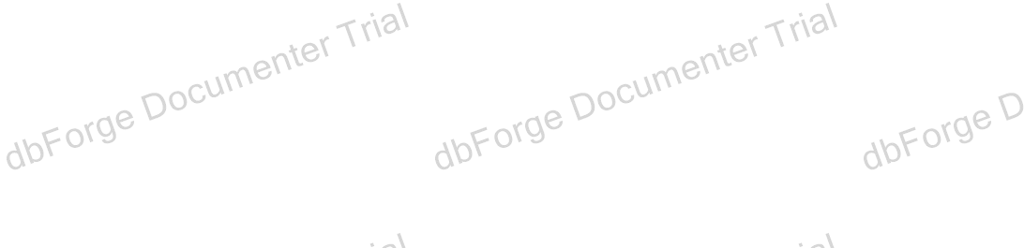

Project / Servers / . / User databases / ExamSystem / Programmability / Types / User-Defined Table Types

User‐Defined Table Types

Objects **1**

|  |  |
| --- | --- |
| **Name** | **Description** |
| dbo.choicetype |  |

Project / Servers / . / User databases / ExamSystem / Programmability / Types / User-Defined Table Types / dbo.choicetype



# dbo.choicetype

Description

Properties

|  |  |
| --- | --- |
| **Name** | **Value** |
| Collation | SQL_Latin1_General_CP1_CI_AS |
| File Group |  |
| Filestream File Group |  |
| Is Partitioned |  |
| Partitioned Column |  |
| Partition Scheme |  |
| File Groups |  |
| Filestream Partition Scheme |  |
| Filestream File Groups |  |
| Heap | **True** |
| Full Text Catalog |  |
| Full Text |  |
| Compression |  |
| Row Count (~) |  |
| Created |  |
| Last Modified |  |

Columns **1**

|  |  |  |  |  |  |  |  |  |  |  |  |
| --- | --- | --- | --- | --- | --- | --- | --- | --- | --- | --- | --- |
| **Key** | **Name** | **Data Type** | **Length** | **Precision** | **Scale** | **Not Null** | **Identity** | **Default** | **Computed** | **Persisted** | **Description** |
|  | choice_text | varchar | 300 | 0 | 0 | **False** |  |  | **False** | **False** |  |

SQL Script

CREATE TYPE dbo.choicetype AS TABLE ( choice_text varchar(300) NULL

) GO

Depends On

No items found

Used By **1**

dbo.sp_insertQuestion



Project / Servers / . / User databases / ExamSystem / Security

Security

Objects **2**

Roles Schemas



Project / Servers / . / User databases / ExamSystem / Security / Roles

Roles

Objects **1**

Database Roles



Project / Servers / . / User databases / ExamSystem / Security / Roles / Database Roles

Database Roles

Objects **10**

|  |  |
| --- | --- |
| **Name** | **Description** |
| db_accessadmin |  |
| db_backupoperator |  |
| db_datareader |  |
| db_datawriter |  |
| db_ddladmin |  |
| db_denydatareader |  |
| db_denydatawriter |  |
| db_owner |  |
| db_securityadmin |  |
| public |  |



Project / Servers / . / User databases / ExamSystem / Security / Roles / Database Roles / db_accessadmin

db_accessadmin

Properties

Members

No items found

SQL Script

Depends On **1**

dbo

Used By

No items found

CREATE ROLE db_accessadmin GO

|  |  |
| --- | --- |
| **Name** | **Value** |
| Owner | dbo |



Project / Servers / . / User databases / ExamSystem / Security / Roles / Database Roles / db_backupoperator

db_backupoperator

Properties

Members

No items found

SQL Script

Depends On **1**

dbo

Used By

No items found

CREATE ROLE db_backupoperator GO

|  |  |
| --- | --- |
| **Name** | **Value** |
| Owner | dbo |



Project / Servers / . / User databases / ExamSystem / Security / Roles / Database Roles / db_datareader

db_datareader

Properties

Members

No items found

SQL Script

Depends On **1**

dbo

Used By

No items found

CREATE ROLE db_datareader GO

|  |  |
| --- | --- |
| **Name** | **Value** |
| Owner | dbo |



Project / Servers / . / User databases / ExamSystem / Security / Roles / Database Roles / db_datawriter

db_datawriter

Properties

Members

No items found

SQL Script

Depends On **1**

dbo

Used By

No items found

CREATE ROLE db_datawriter GO

|  |  |
| --- | --- |
| **Name** | **Value** |
| Owner | dbo |



Project / Servers / . / User databases / ExamSystem / Security / Roles / Database Roles / db_ddladmin

db_ddladmin

Properties

Members

No items found

SQL Script

Depends On **1**

dbo

Used By

No items found

CREATE ROLE db_ddladmin GO

|  |  |
| --- | --- |
| **Name** | **Value** |
| Owner | dbo |



Project / Servers / . / User databases / ExamSystem / Security / Roles / Database Roles / db_denydatareader

db_denydatareader

Properties

Members

No items found

SQL Script

Depends On **1**

dbo

Used By

No items found

CREATE ROLE db_denydatareader GO

|  |  |
| --- | --- |
| **Name** | **Value** |
| Owner | dbo |



Project / Servers / . / User databases / ExamSystem / Security / Roles / Database Roles / db_denydatawriter

db_denydatawriter

Properties

Members

No items found

SQL Script

Depends On **1**

dbo

Used By

No items found

CREATE ROLE db_denydatawriter GO

|  |  |
| --- | --- |
| **Name** | **Value** |
| Owner | dbo |

|  |  |
| --- | --- |
| **Name** | **Value** |
| Owner | dbo |

No items found



Project / Servers / . / User databases / ExamSystem / Security / Roles / Database Roles / db_owner

db_owner

Properties

Members **1**

dbo

SQL Script

Depends On **1**

dbo

Used By

CREATE ROLE db_owner GO

EXEC sp_addrolemember N'db_owner', N'dbo' GO



Project / Servers / . / User databases / ExamSystem / Security / Roles / Database Roles / db_securityadmin

db_securityadmin

Properties

Members

No items found

SQL Script

Depends On **1**

dbo

Used By

No items found

CREATE ROLE db_securityadmin GO

|  |  |
| --- | --- |
| **Name** | **Value** |
| Owner | dbo |



Project / Servers / . / User databases / ExamSystem / Security / Roles / Database Roles / public

public

Properties

Members

No items found

Database Level Permissions **2**

SQL Script

Depends On **1**

dbo

Used By

No items found

CREATE ROLE [public] GO

|  |  |
| --- | --- |
| **Name** | **Value** |
| Owner | dbo |

|  |  |
| --- | --- |
| **Type** | **Action** |
| Grant | VIEW ANY COLUMN ENCRYPTION KEY DEFINITION |
| Grant | VIEW ANY COLUMN MASTER KEY DEFINITION |



Project / Servers / . / User databases / ExamSystem / Security / Schemas

Schemas

Objects **14**

|  |  |
| --- | --- |
| **Name** | **Description** |
| db_accessadmin |  |
| db_backupoperator |  |
| db_datareader |  |
| db_datawriter |  |
| db_ddladmin |  |
| db_denydatareader |  |
| db_denydatawriter |  |
| db_owner |  |
| db_securityadmin |  |
| dbo |  |
| guest |  |
| INFORMATION_SCHEMA |  |
| std |  |
| sys |  |

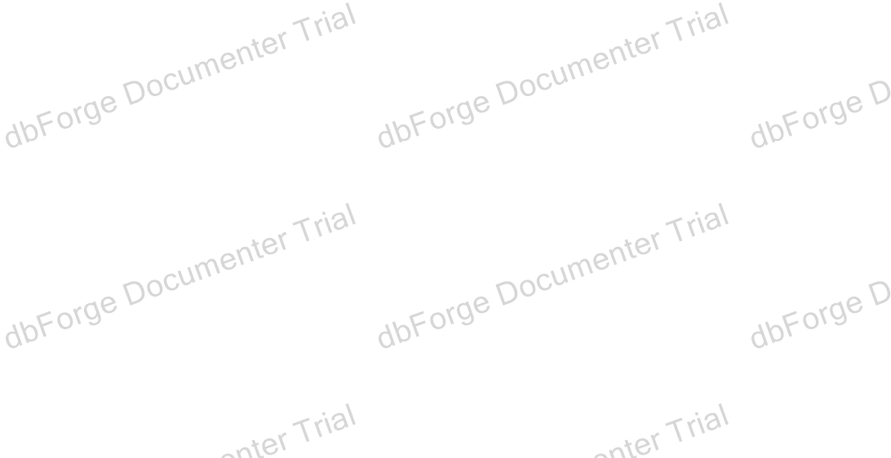

Project / Servers / . / User databases / ExamSystem / Security / Schemas / db_accessadmin

db_accessadmin

Properties

SQL Script

Depends On

No items found

Used By

No items found

CREATE SCHEMA db_accessadmin AUTHORIZATION db_accessadmin GO

|  |  |
| --- | --- |
| **Name** | **Value** |
| Owner | db_accessadmin |



Project / Servers / . / User databases / ExamSystem / Security / Schemas / db_backupoperator

db_backupoperator

Properties

SQL Script

Depends On

No items found

Used By

No items found

CREATE SCHEMA db_backupoperator AUTHORIZATION db_backupoperator GO

|  |  |
| --- | --- |
| **Name** | **Value** |
| Owner | db_backupoperator |



Project / Servers / . / User databases / ExamSystem / Security / Schemas / db_datareader

db_datareader

Properties

SQL Script

Depends On

No items found

Used By

No items found

CREATE SCHEMA db_datareader AUTHORIZATION db_datareader GO

|  |  |
| --- | --- |
| **Name** | **Value** |
| Owner | db_datareader |



Project / Servers / . / User databases / ExamSystem / Security / Schemas / db_datawriter

db_datawriter

Properties

SQL Script

Depends On

No items found

Used By

No items found

CREATE SCHEMA db_datawriter AUTHORIZATION db_datawriter GO

|  |  |
| --- | --- |
| **Name** | **Value** |
| Owner | db_datawriter |



Project / Servers / . / User databases / ExamSystem / Security / Schemas / db_ddladmin

db_ddladmin

Properties

SQL Script

Depends On

No items found

Used By

No items found

CREATE SCHEMA db_ddladmin AUTHORIZATION db_ddladmin GO

|  |  |
| --- | --- |
| **Name** | **Value** |
| Owner | db_ddladmin |



Project / Servers / . / User databases / ExamSystem / Security / Schemas / db_denydatareader

db_denydatareader

Properties

SQL Script

Depends On

No items found

Used By

No items found

CREATE SCHEMA db_denydatareader AUTHORIZATION db_denydatareader GO

|  |  |
| --- | --- |
| **Name** | **Value** |
| Owner | db_denydatareader |



Project / Servers / . / User databases / ExamSystem / Security / Schemas / db_denydatawriter

db_denydatawriter

Properties

SQL Script

Depends On

No items found

Used By

No items found

CREATE SCHEMA db_denydatawriter AUTHORIZATION db_denydatawriter GO

|  |  |
| --- | --- |
| **Name** | **Value** |
| Owner | db_denydatawriter |



Project / Servers / . / User databases / ExamSystem / Security / Schemas / db_owner

db_owner

Properties

SQL Script

Depends On

No items found

Used By

No items found

CREATE SCHEMA db_owner AUTHORIZATION db_owner GO

|  |  |
| --- | --- |
| **Name** | **Value** |
| Owner | db_owner |



Project / Servers / . / User databases / ExamSystem / Security / Schemas / db_securityadmin

db_securityadmin

Properties

SQL Script

Depends On

No items found

Used By

No items found

CREATE SCHEMA db_securityadmin AUTHORIZATION db_securityadmin GO

|  |  |
| --- | --- |
| **Name** | **Value** |
| Owner | db_securityadmin |



Project / Servers / . / User databases / ExamSystem / Security / Schemas / dbo

dbo

Description

Properties

SQL Script

Depends On

No items found

Used By

No items found

CREATE SCHEMA dbo AUTHORIZATION dbo GO

|  |  |
| --- | --- |
| **Name** | **Value** |
| Owner | dbo |



Project / Servers / . / User databases / ExamSystem / Security / Schemas / guest

guest

Description

Properties

SQL Script

Depends On

No items found

Used By

No items found

CREATE SCHEMA guest AUTHORIZATION guest GO

|  |  |
| --- | --- |
| **Name** | **Value** |
| Owner | guest |



Project / Servers / . / User databases / ExamSystem / Security / Schemas / INFORMATION_SCHEMA

INFORMATION_SCHEMA

Properties

SQL Script

Depends On

No items found

Used By

No items found

CREATE SCHEMA INFORMATION_SCHEMA AUTHORIZATION INFORMATION_SCHEMA GO

|  |  |
| --- | --- |
| **Name** | **Value** |
| Owner | INFORMATION_SCHEMA |



Project / Servers / . / User databases / ExamSystem / Security / Schemas / std

std

Description

Properties

SQL Script

Depends On **1**

dbo

Used By **1**

std.Student

CREATE SCHEMA std AUTHORIZATION dbo GO

|  |  |
| --- | --- |
| **Name** | **Value** |
| Owner | dbo |



Project / Servers / . / User databases / ExamSystem / Security / Schemas / sys

sys

Properties

SQL Script

Depends On

No items found

Used By

No items found

CREATE SCHEMA sys AUTHORIZATION sys GO

|  |  |
| --- | --- |
| **Name** | **Value** |
| Owner | sys |